Tiny Car

Assembly instructons

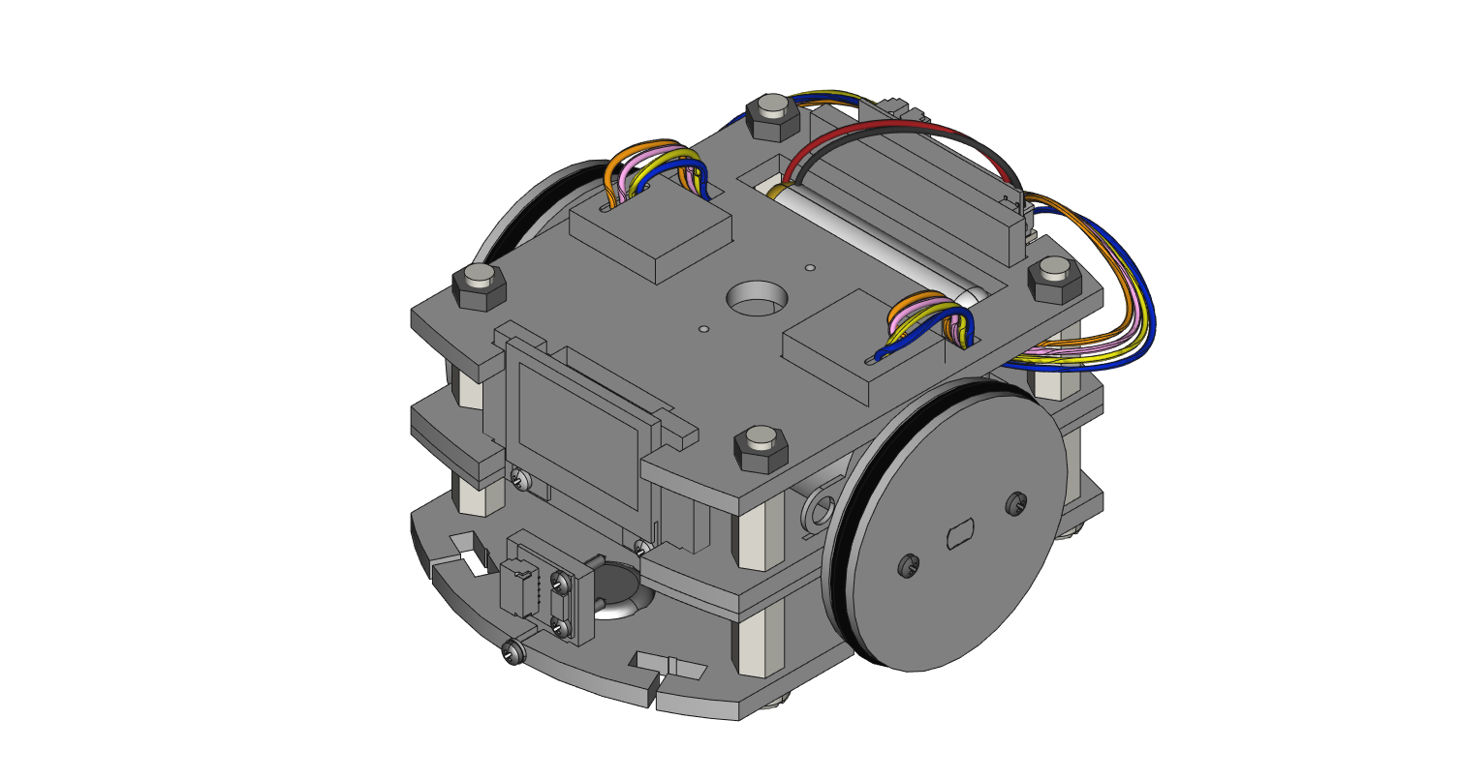



Required Supplies for Structure Assembly

* 4 × #0 Screw size small flat metal washers
* 25 × M1.4 x 8mm self-tapping screws
* 4 × 6-32 1.5” Nylon screws
* 4 × 6-32 hex nuts
* 8 × 6-32 0.5” aluminum hex spacers
* 2 × Bipolar 5V stepper motors
* 2 × Ball casters
* 2 × Large O-rings (used on wheels)
* 4 × Small O-rings (used to attach RobotZero to acrylic)
* 4 × 100mm 5-pin Wireling cables
* 4 × Small nylons spacers [ID: 2.3mm, OD: 3.2mm, Height: 3mm]
* 5 × 0.060” Thin acrylic parts
  + 1 × CA2 part
  + 2 × CA7 parts
  + 2 × CA9 parts
* 10 × 0.118” Thick acrylic parts
  + 1 × CA1 part
  + 1 × CA3 parts
  + 1 × CA4 part
  + 1 × CA5 part
  + 1 × CA6 part
  + 2 × CA8 part
  + 3 × M1 parts
  + 3 × M2 parts
* Required Tools
  + 1 × Small Philips screwdriver for M1.4 x 8mm screws [#00]
  + 1 × Small flathead screwdriver for board mounting screws [1.5mm]
* Recommended Tools
  + 1 × Large flathead screwdriver for nylon screws [#1]
  + 1 × Tweezers for small parts and routing cables

**STEP 0**: **Remove Acrylic Covering**. Once the paper is removed, try your best not to directly touch the acrylic (handle by the edges) as fingerprints show easily.

Visit our website at <https://tinycircuits.com> or email us at [info@tinycircuits.com](mailto:info@tinycircuits.com) for questions or help

**STEP 1**: **Assembling Car**. Start with piece CA1 and insert two ball casters. Use even pressure to insert casters – otherwise you may risk cracking the acrylic.

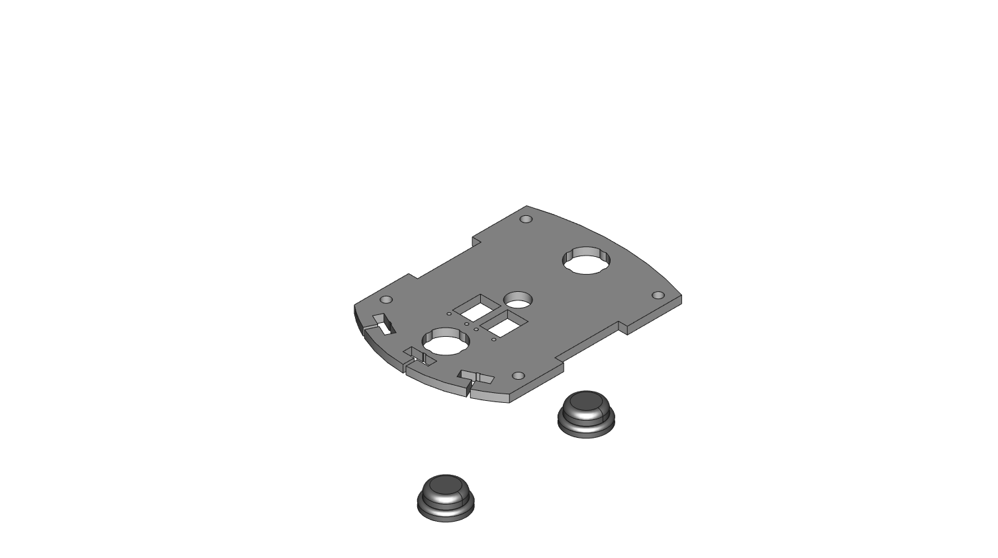

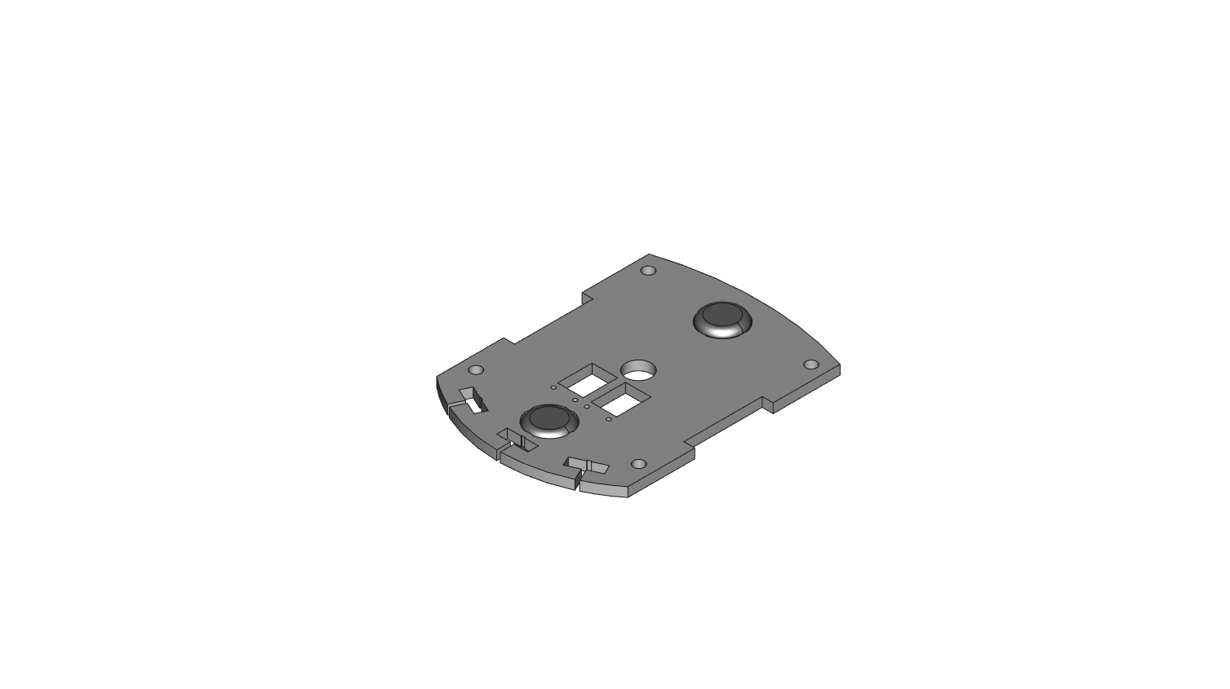

**STEP 2**: Use 4 1.5” white nylon screws and insert them into the four corner holes

.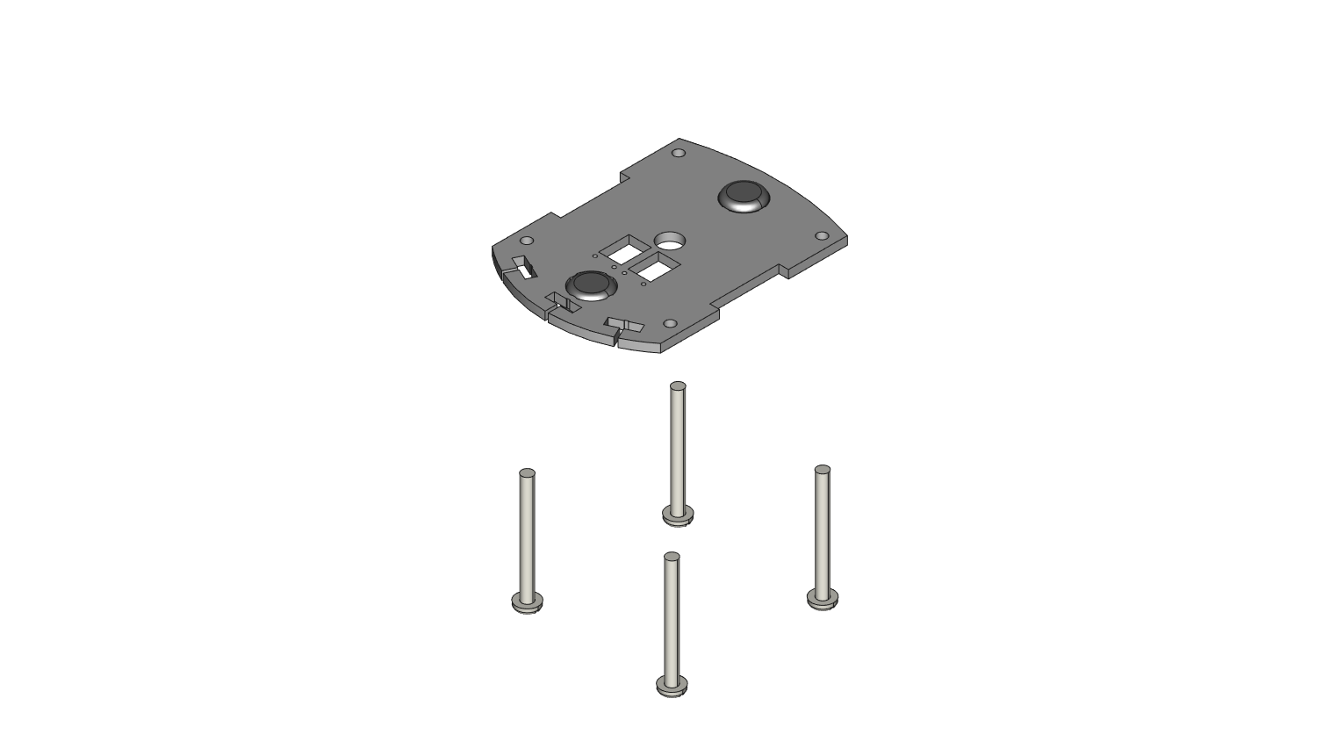

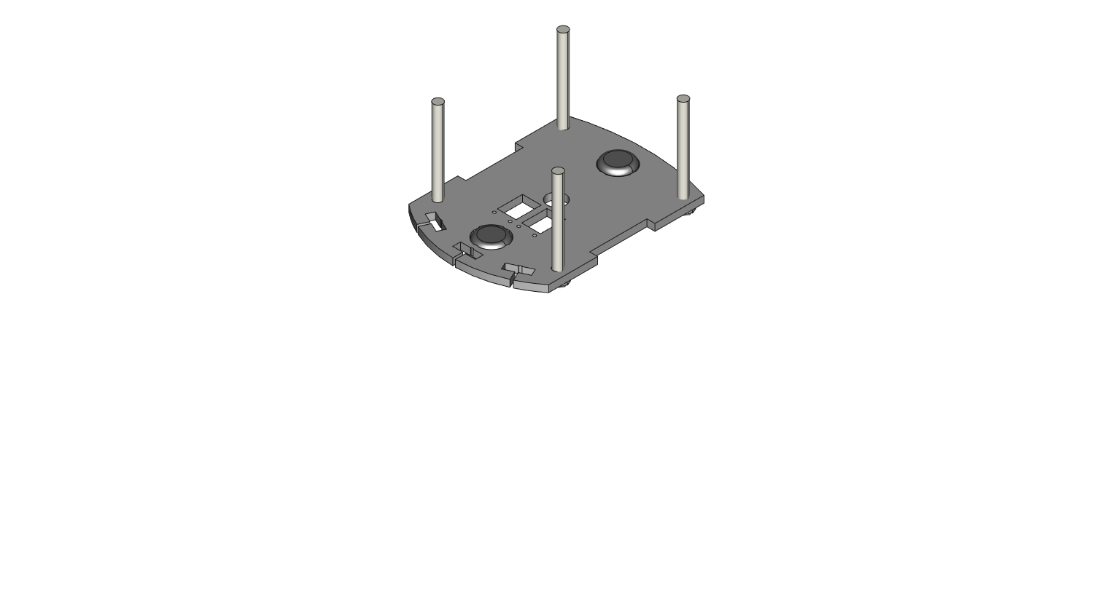

**STEP 4**: Screw on 4 0.5” aluminum hex spacers onto the 4 nylon screws.

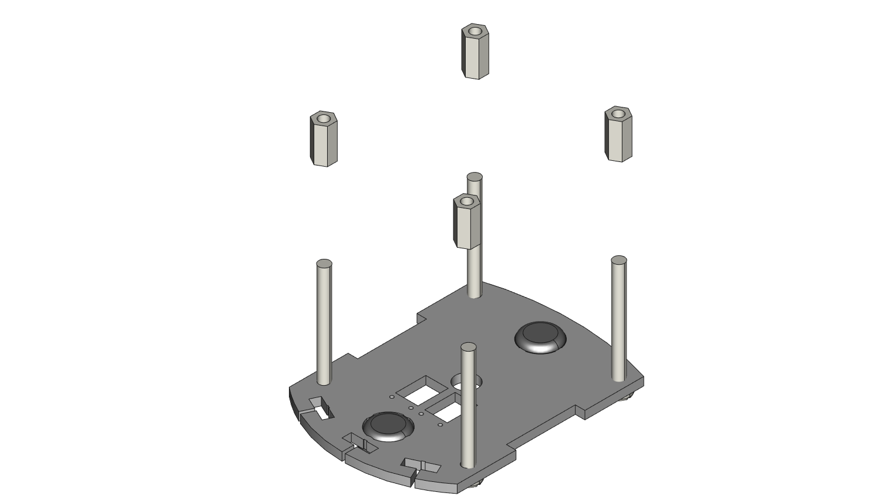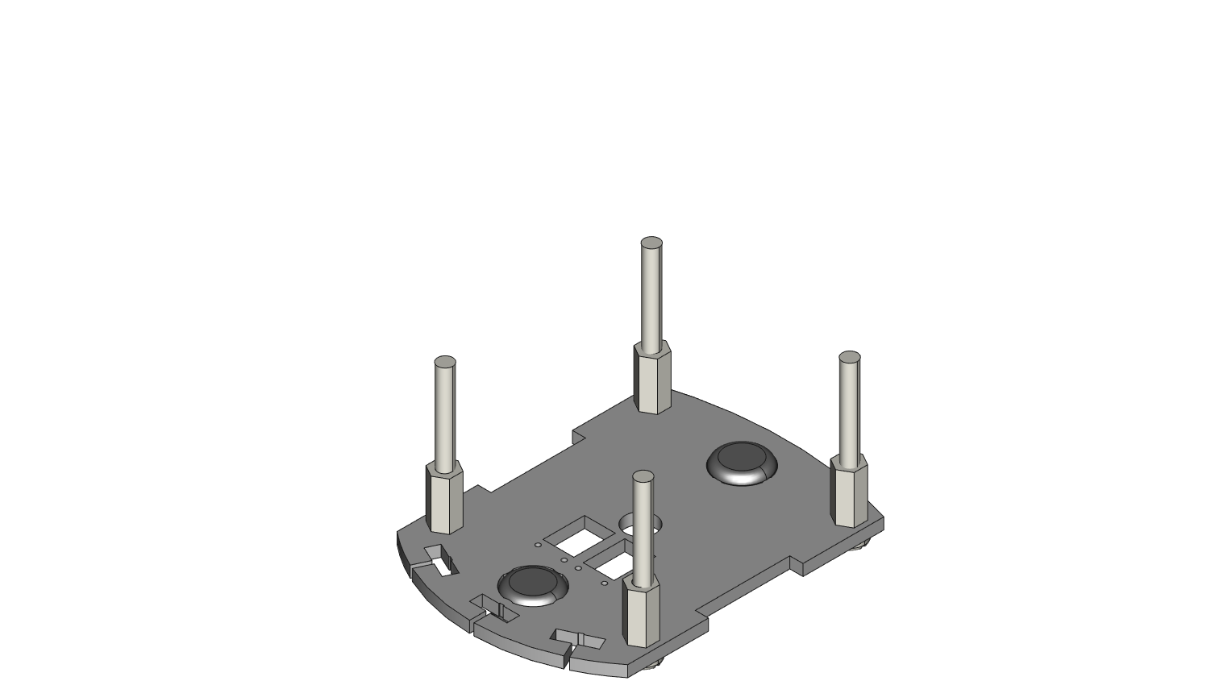

**STEP 5**: Put part CA2 on top of the 4 nylon hex spacers. Check the orientation of the parts while doing so. NOTE: To get the correct orientation for the screw slots make sure that the side with the engraved letters “CA2” is facing up as the part is threaded by the nylon screws.

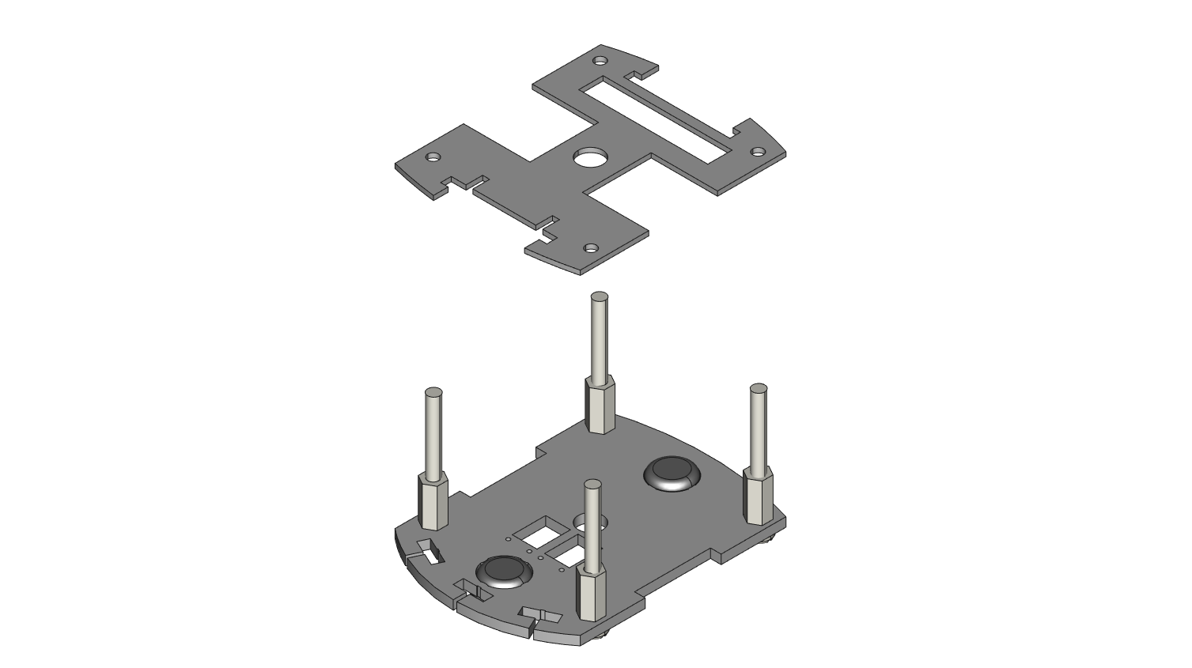

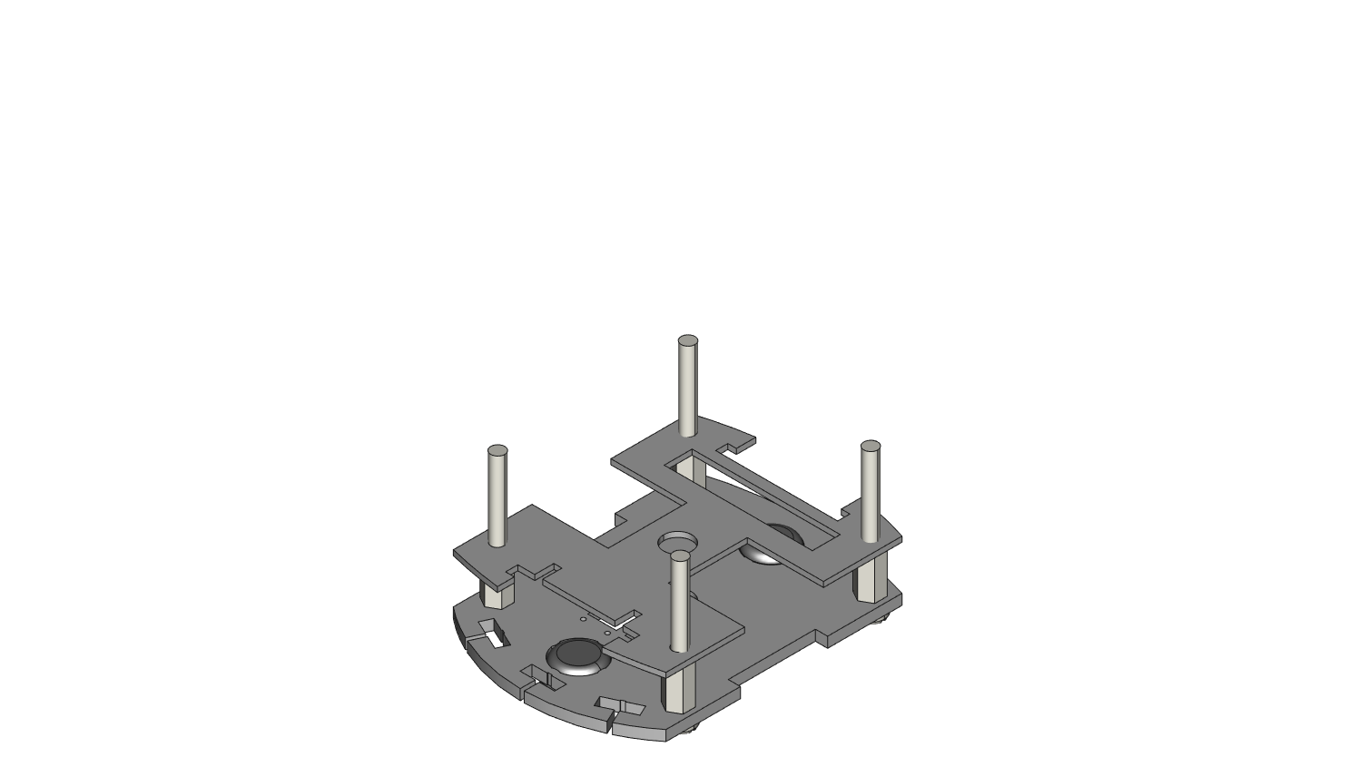

**STEP 6**: Put part CA3 on top of the CA2. Again, make sure the side with the engraved part number “CA3” is facing up when threaded by the screws.

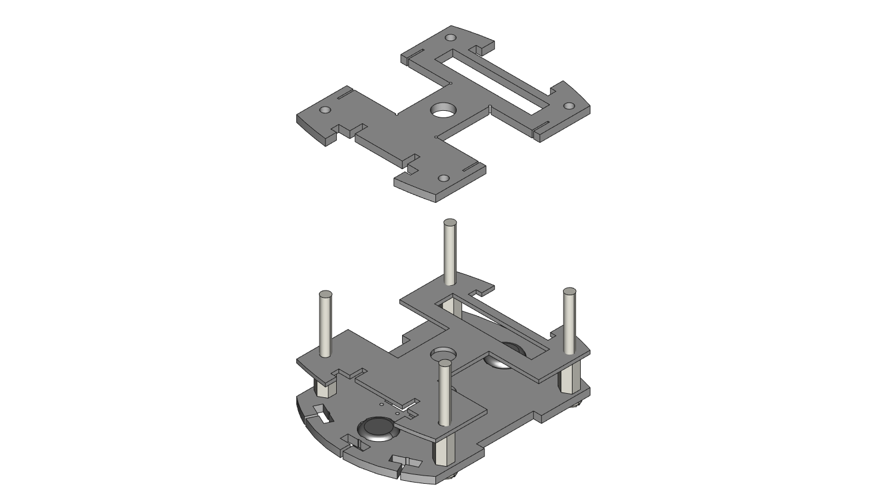

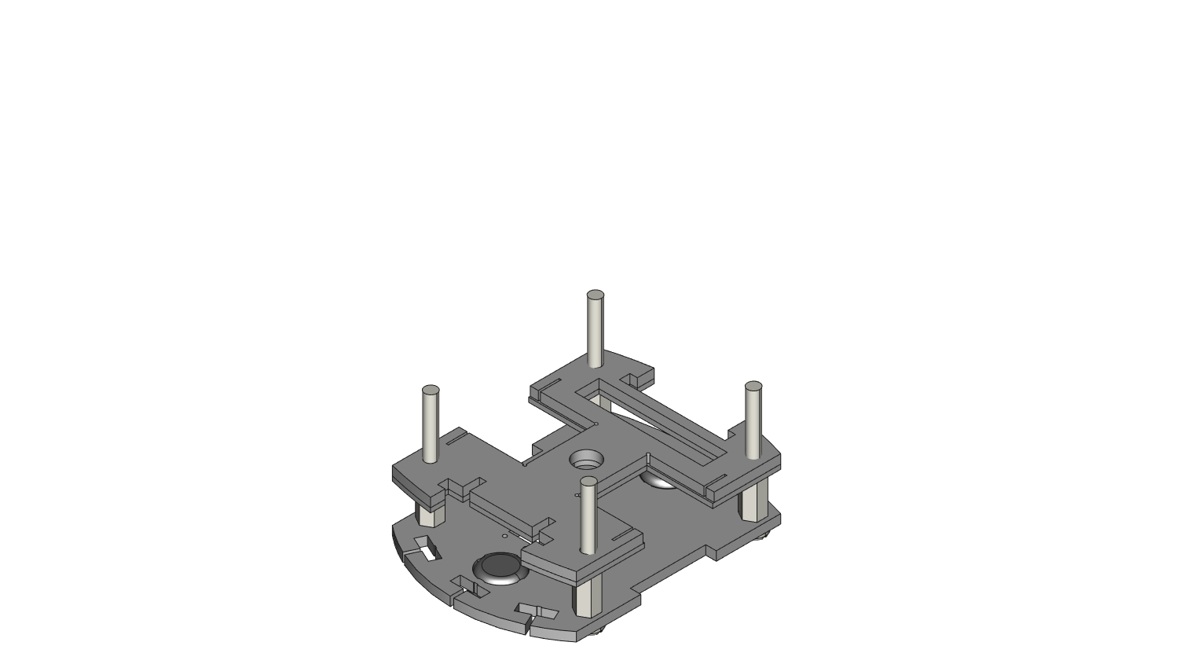

**STEP 7**: Screw on 4 0.5” hex spacers onto the 4 nylon screws until flush with CA3.

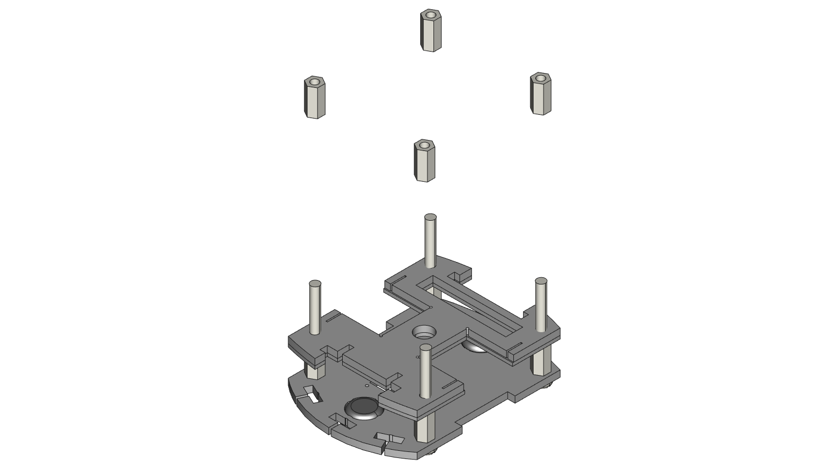

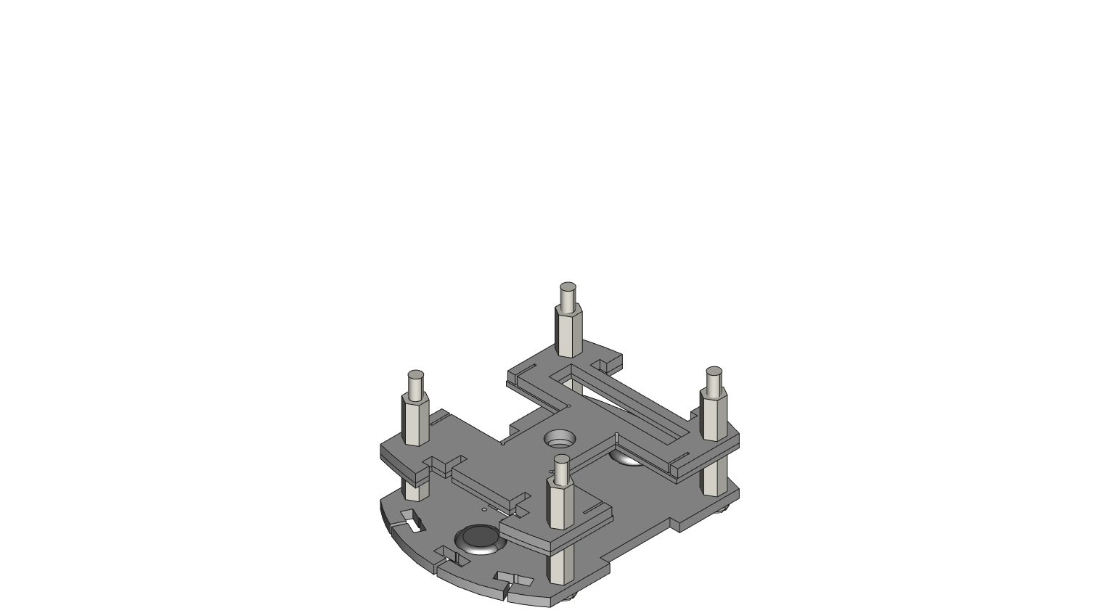

**STEP 8**: Insert 2 stepper motors into the slots on parts CA2 and CA3. Make sure the wings on the stepper motors line up with the slits in each slot. NOTE: Do not force the parts in here, the wings on the motors are not meant to insert completely into the slots on part CA3. The wings should only insert about halfway or less into the slots.

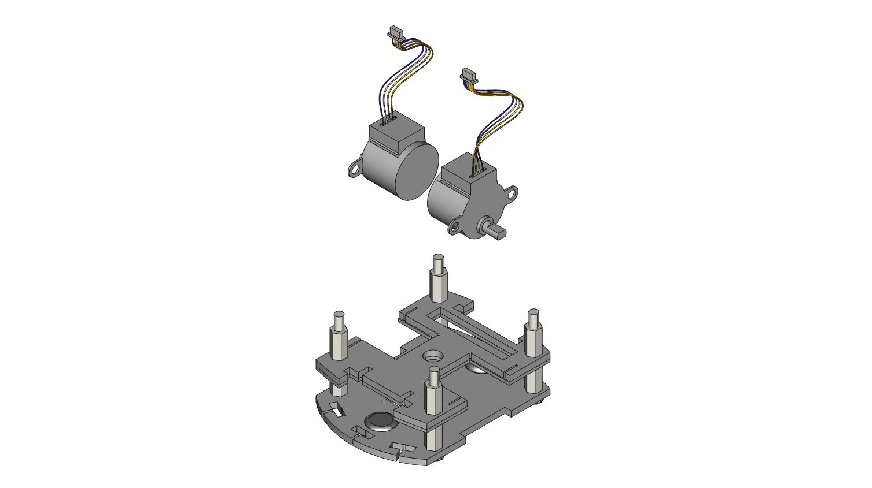

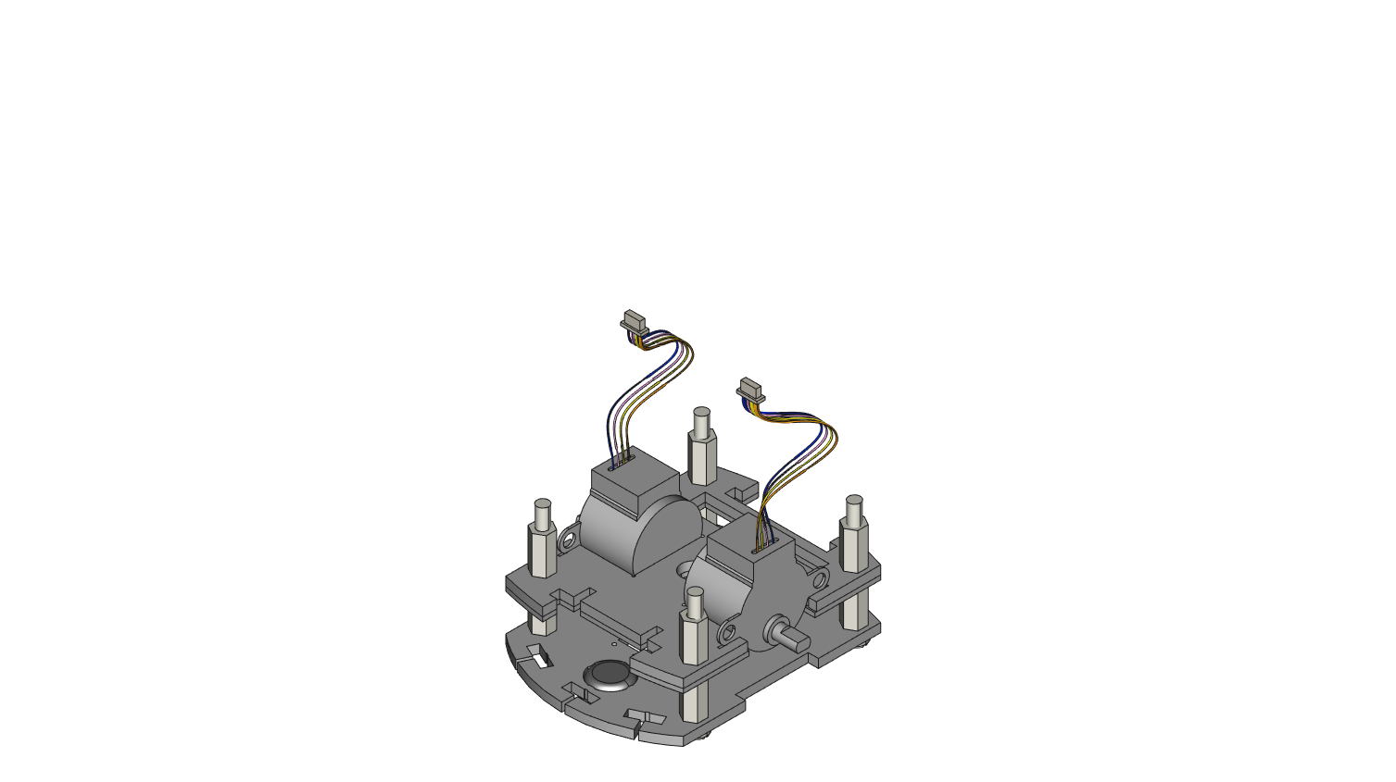

**STEP 9**: Rest piece CA4 on a flat surface and place 4 3mm small nylon spacers on the board, one per hole. *Do this step in conjunction with the next three steps*.

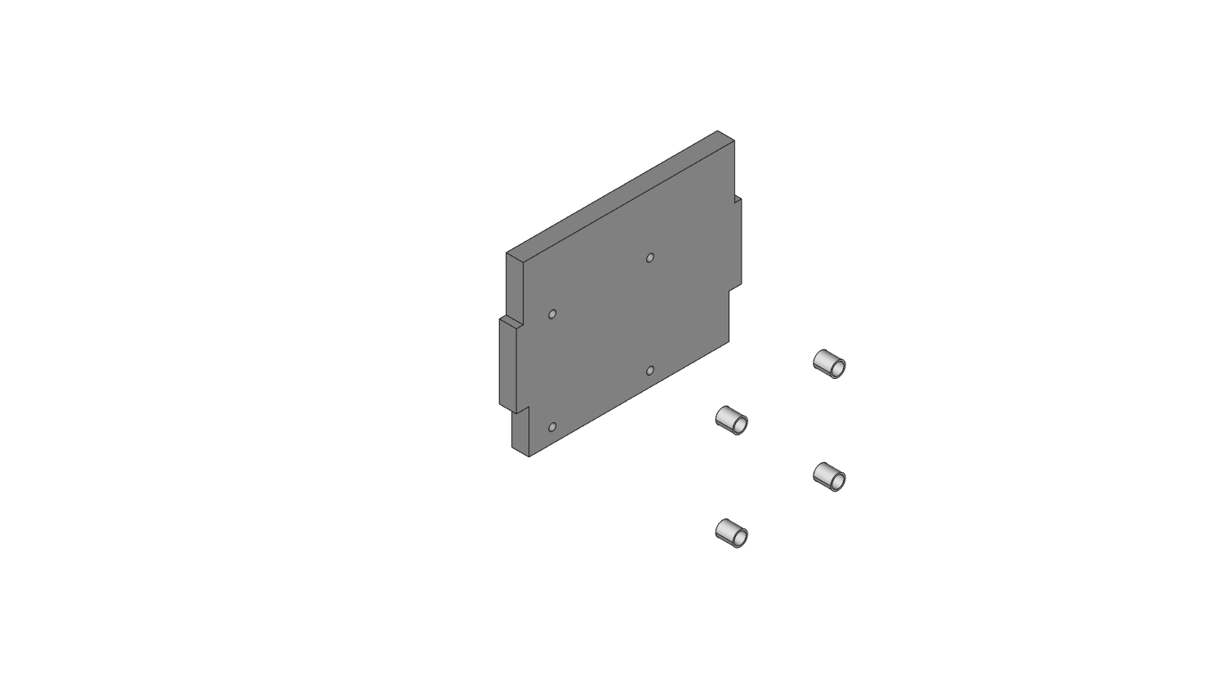

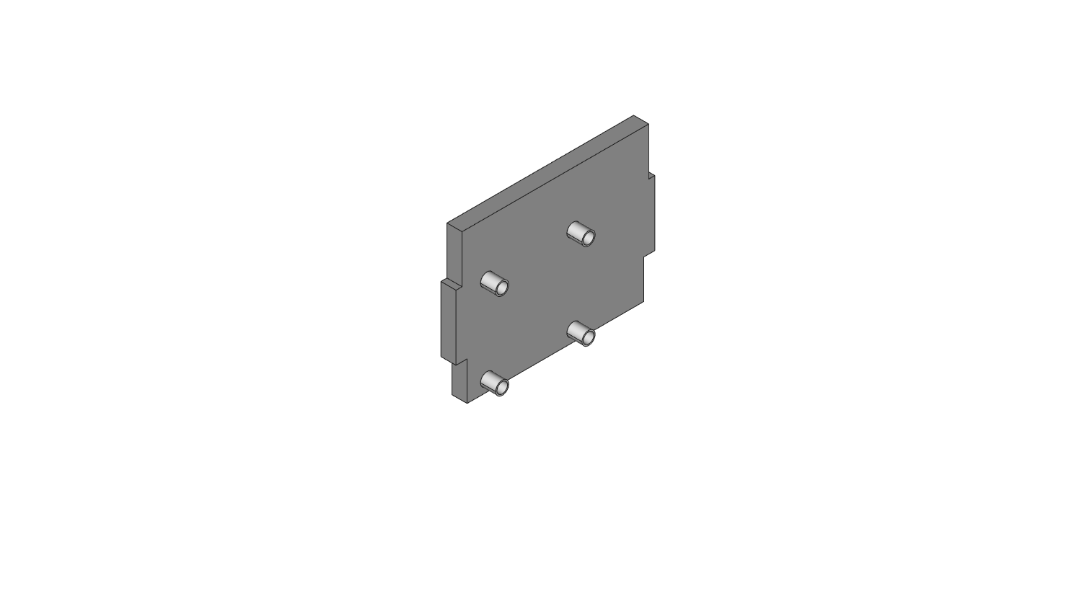

**STEP 10**: The RobotZero board will be pressed against the white spacers after attaching the board with screws. *Again, do this step at the same time as the last and next two steps.*

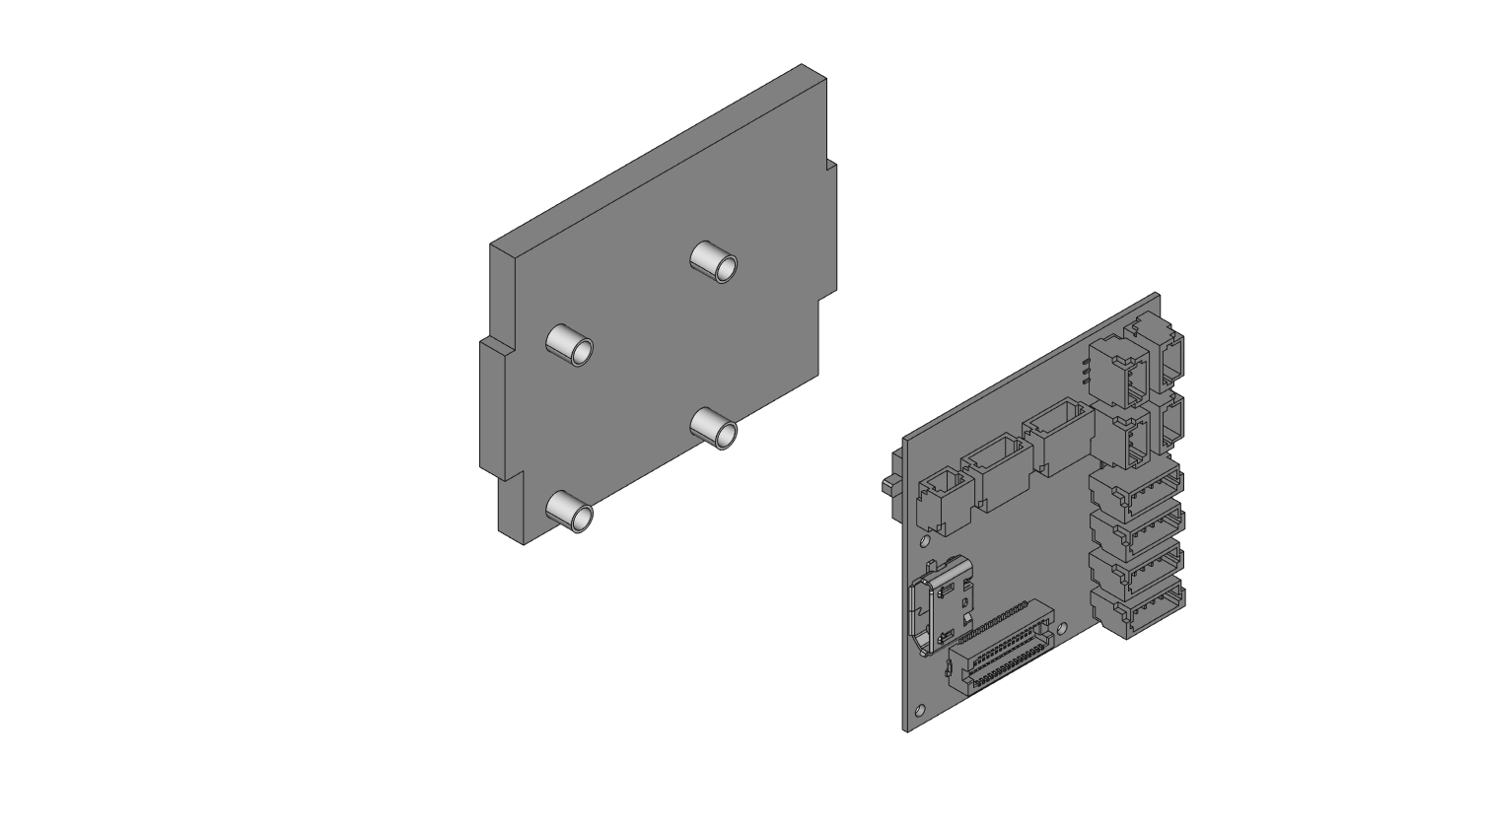

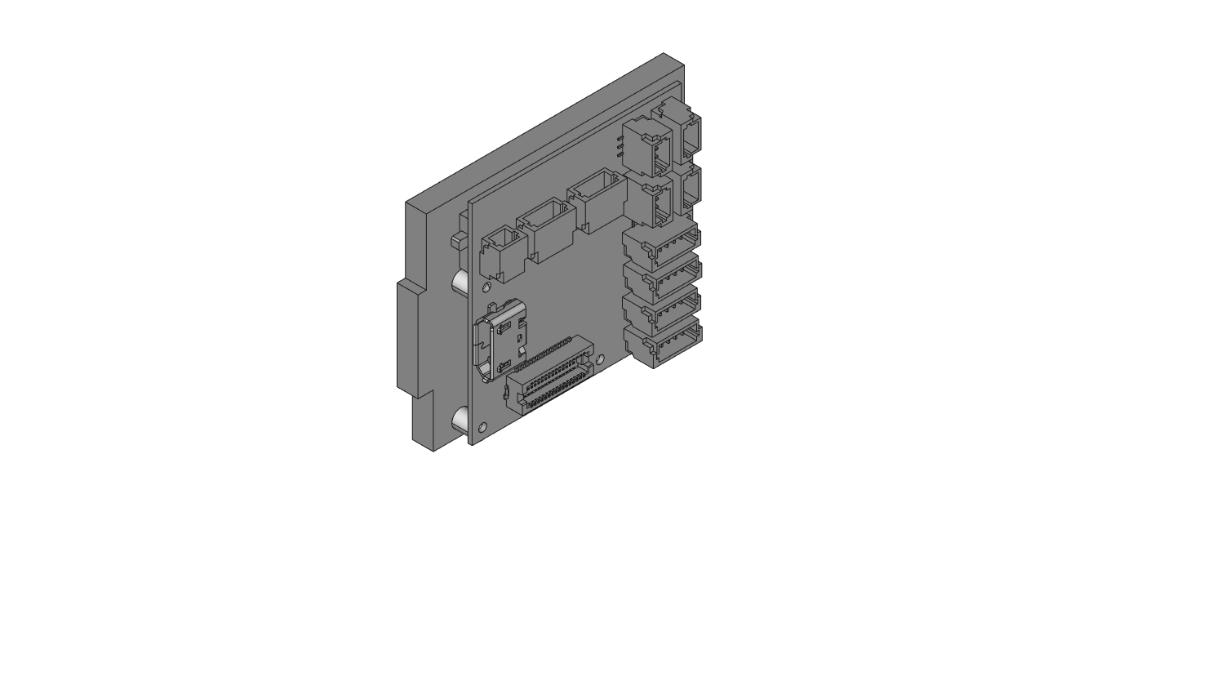

**STEP 11**: Use 4 small #000 rubber O-rings and place one on each mounting hole of the RobotZero.

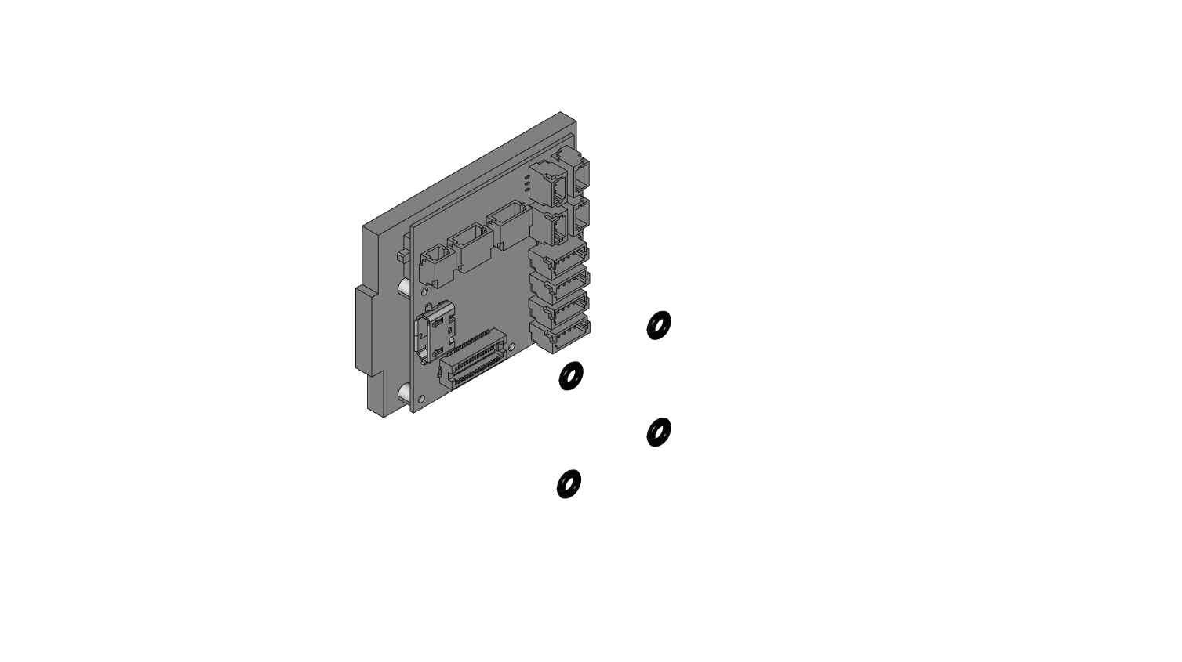

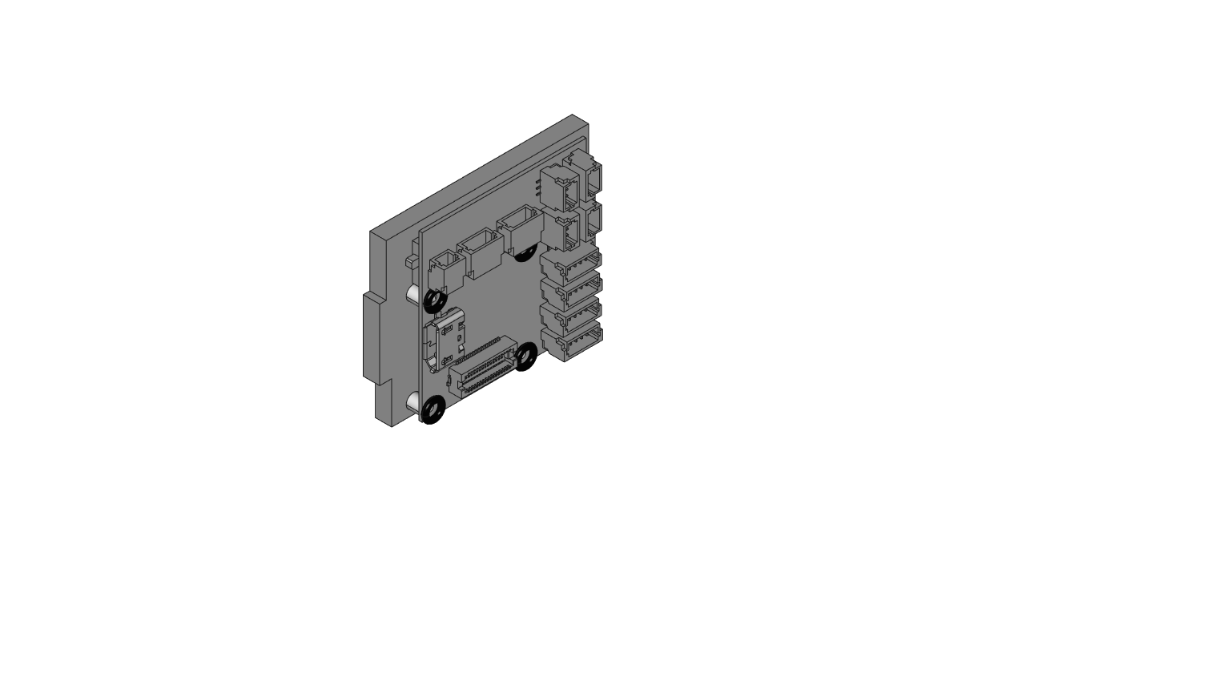

**STEP 12**: Use 4 M1.4 x 8mm tapping screws to attach the spacers and the RobotZero board to CA4. *NOTE: Threading the screws into the boards may be easier after focusing on inserting just one screw.*

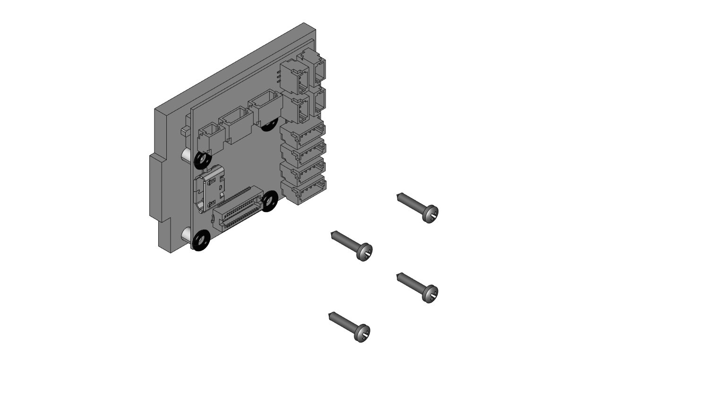

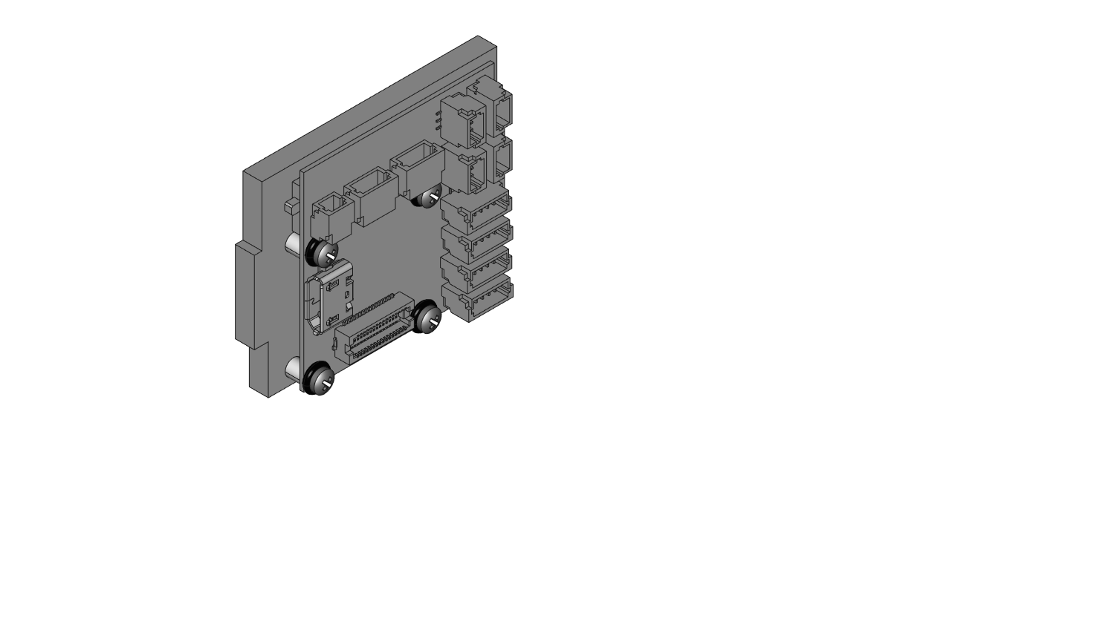

**STEP 13**: Insert CA4 into the back slot on part CA5. Notice that the view is looking from behind or at the back of the robot assembly this time.

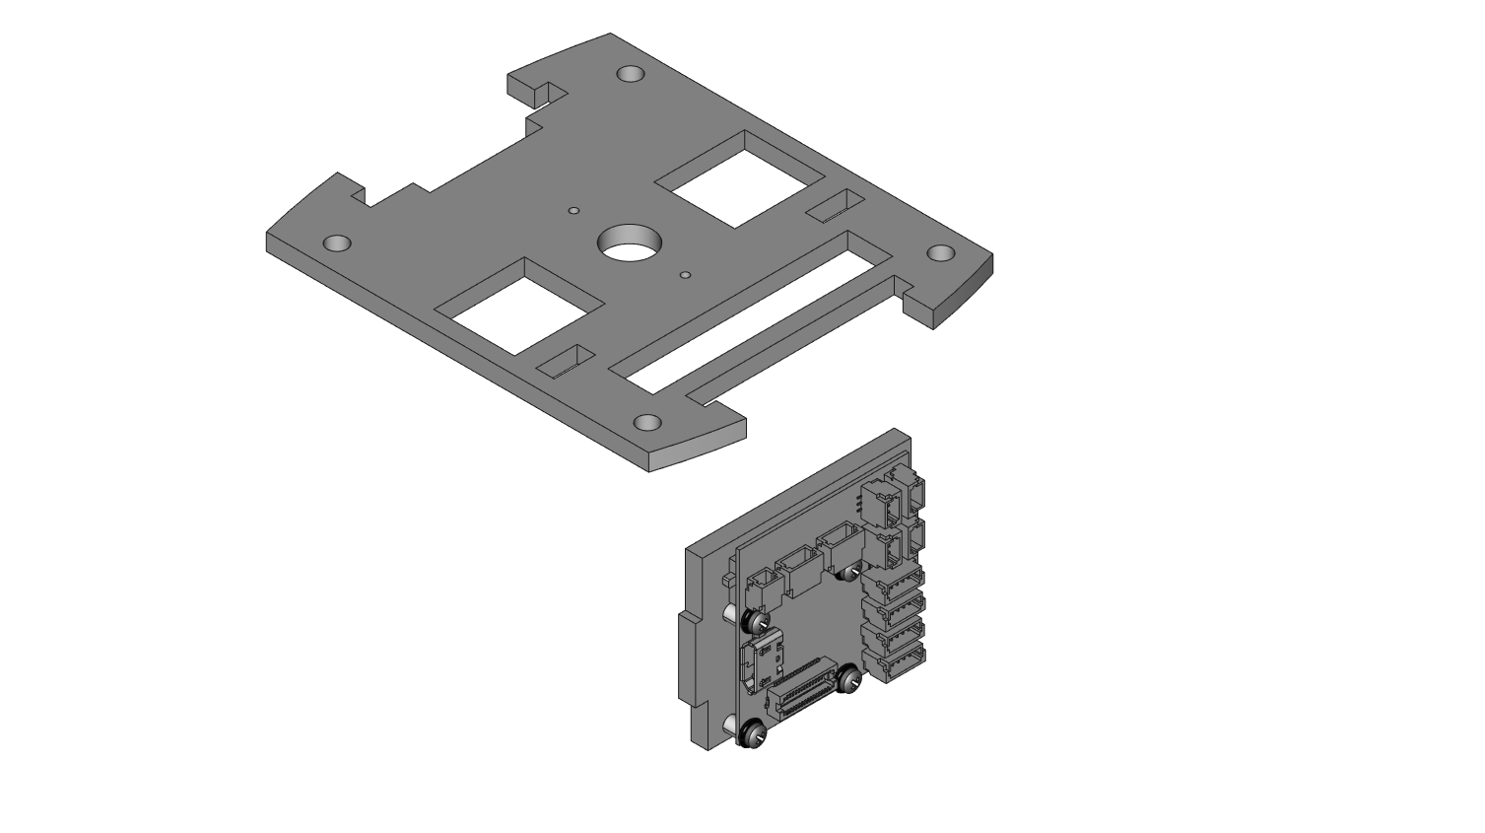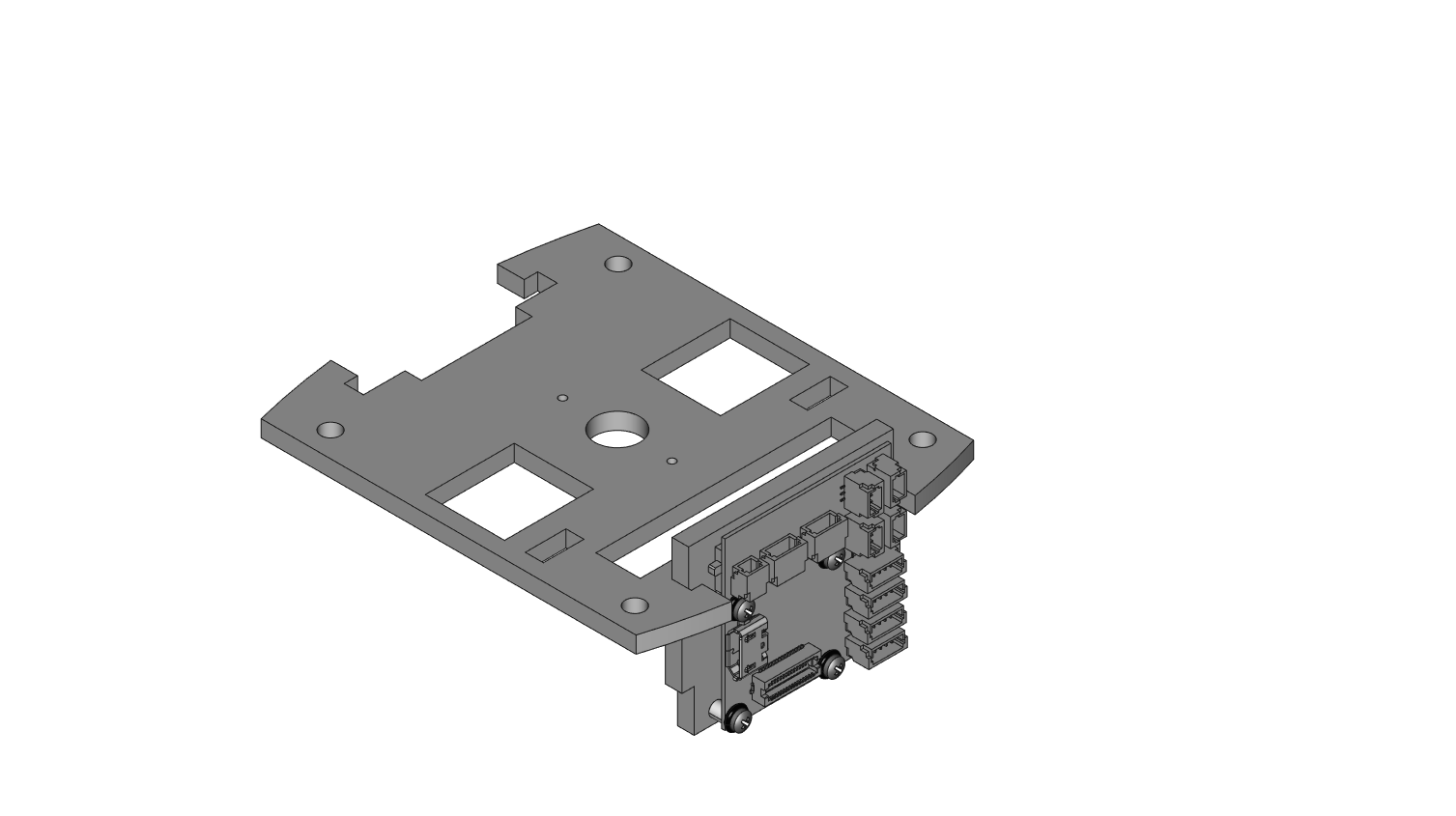

**STEP 14**: Place part CA6 into part CA5 using the front slot.

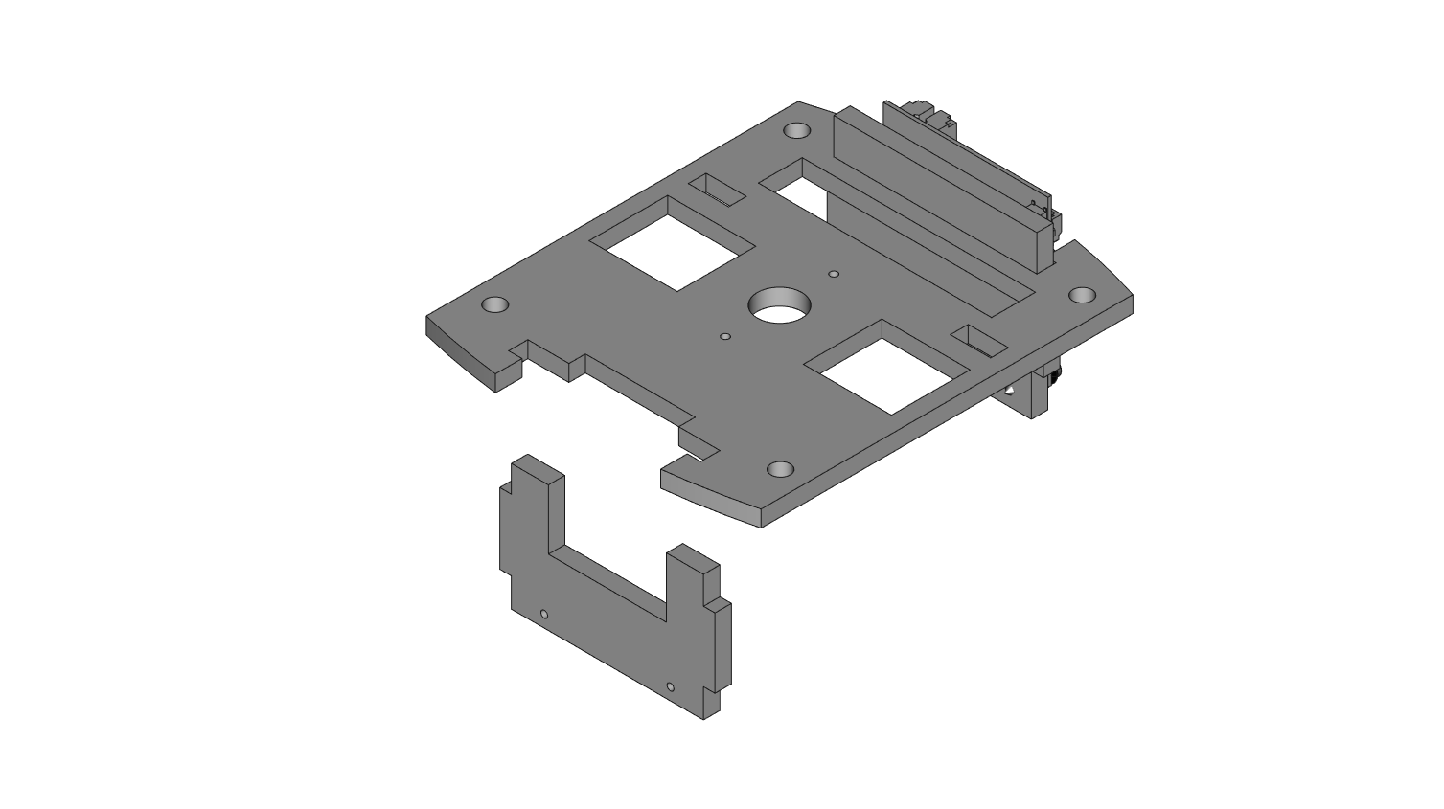

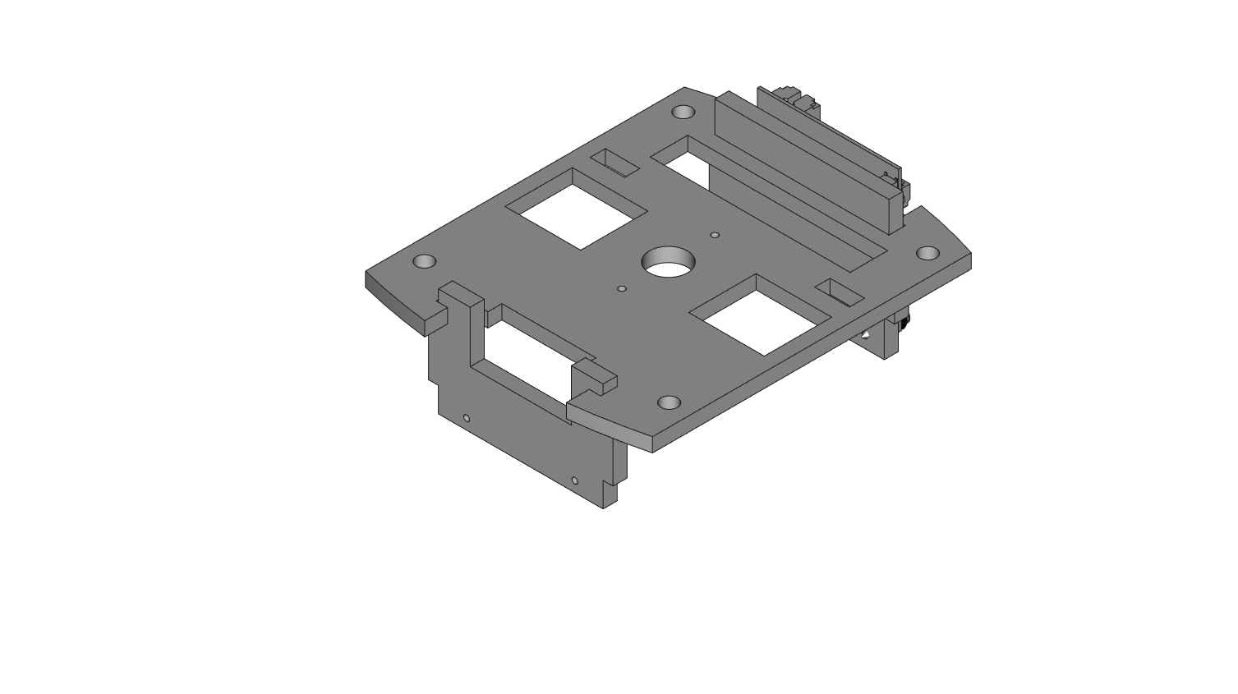

**STEP 15**: Take the 0.96” Wireling screen and prepare to mount it to CA5. Use 1 100mm 5-pin Wireling wire and plug it into the port on the of back the screen. The wire is not shown here but it will be routed through the car. *NOTE: Handle the 0.96” Screen Wireling with care, too much pressure or force can crack the screen.*

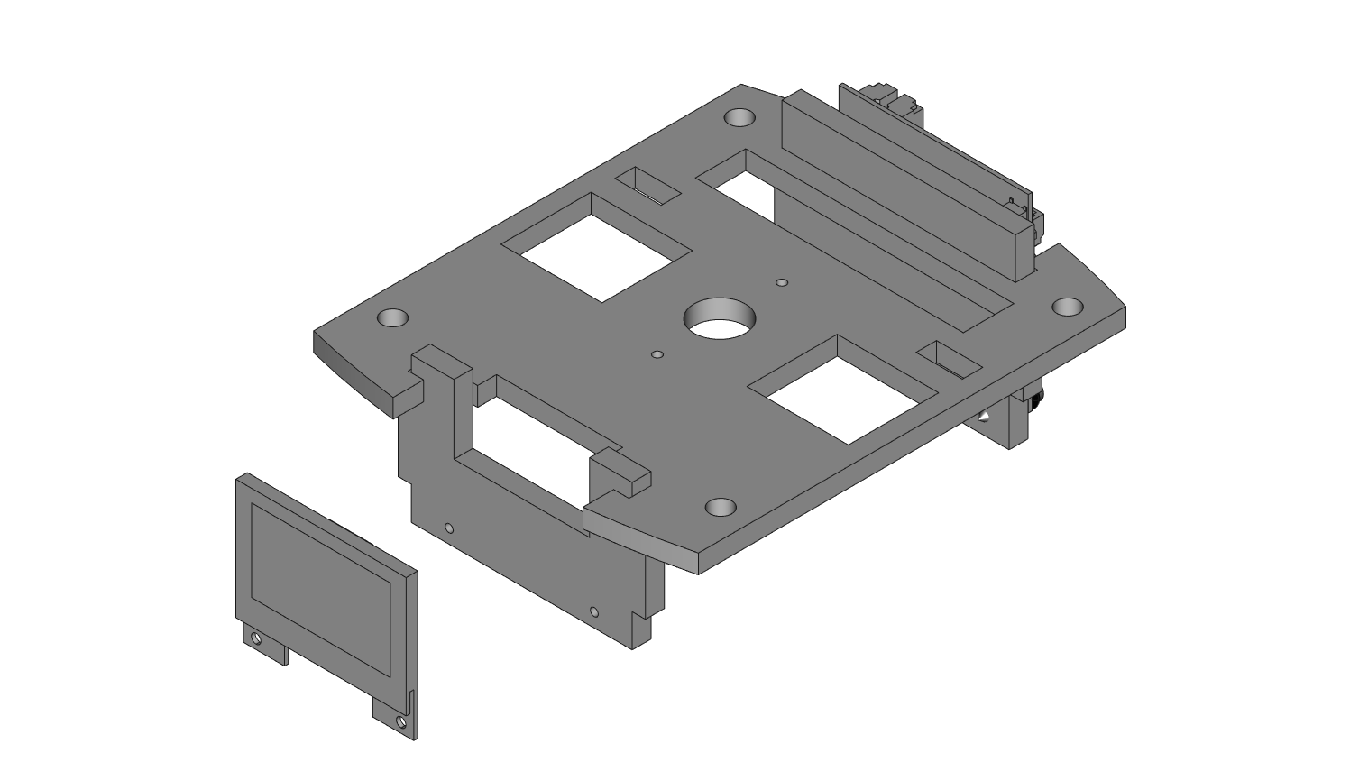

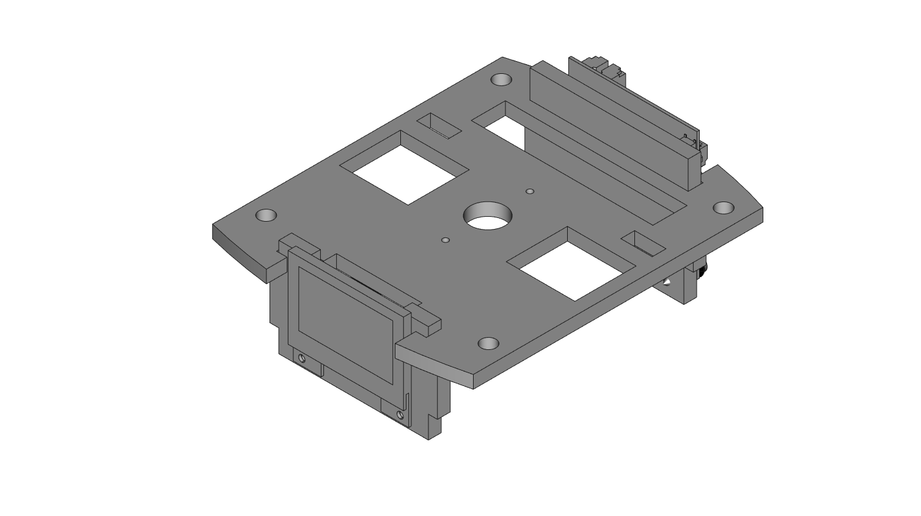

**STEP 16**: Use 2 M1.4 x 8mm tapping screws and mount the screen to part CA6.

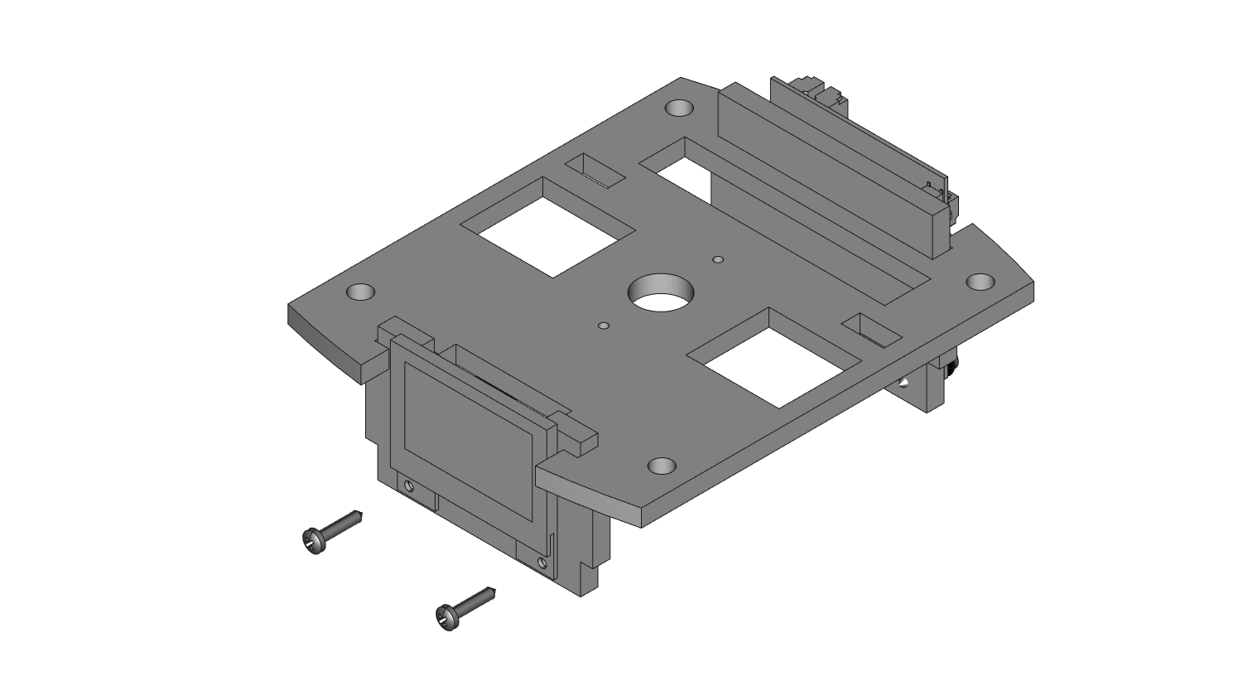

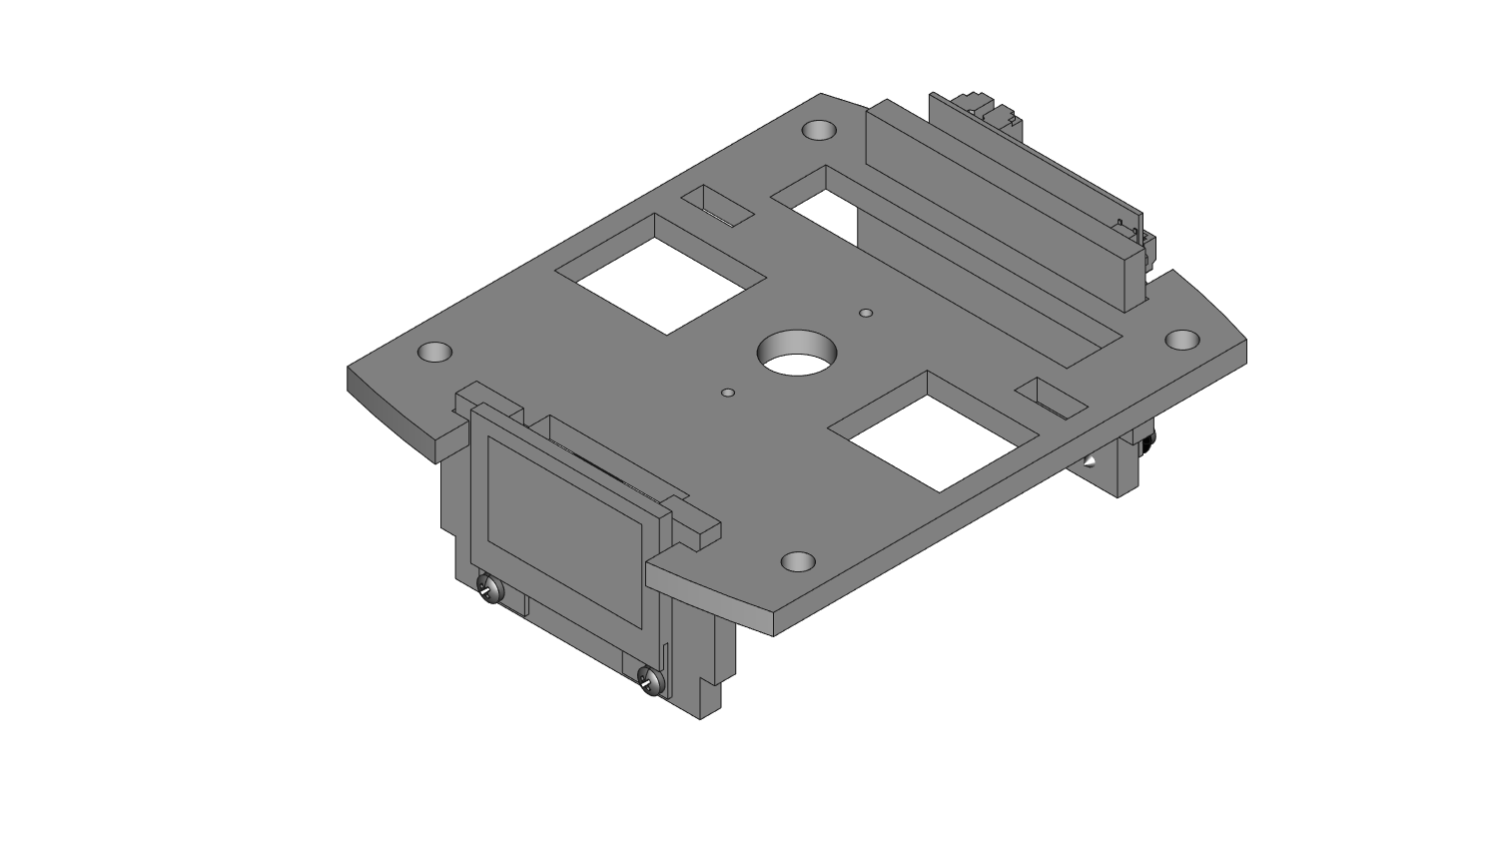

**STEP 17**: CA4 to CA6 can be placed over top of the motors as shown. The stepper motor wires go through the slots on CA5 and the motors themselves push into the same slots. Line up the slots for CA4 and CA6 to rest in on CA3. Watch that the motor wings do not slip out of the slots on CA3. NOTE: The screws through CA4 can make it hard to push CA4 down into the slot. Try loosening the bottom two screws that mount the board. *This step takes patience, do not force the acrylic to fit as you can crack it with too much force.*

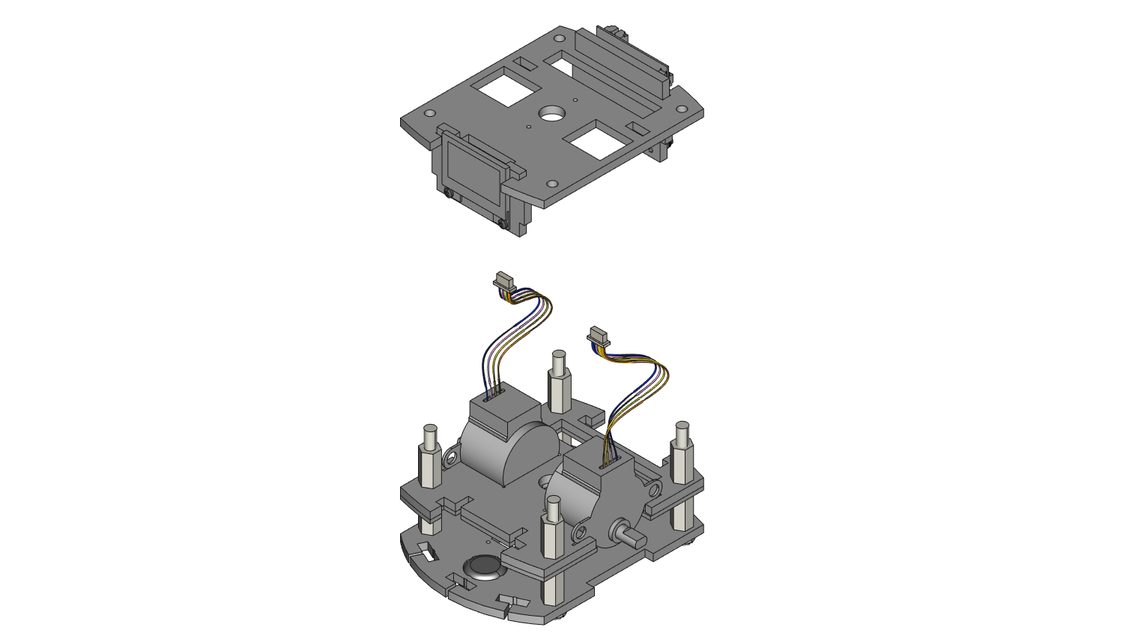

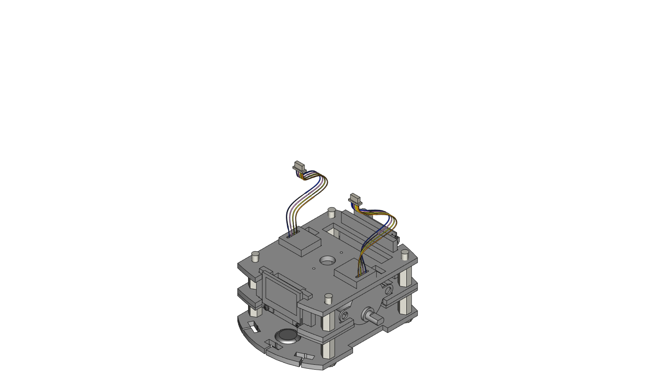

**STEP 18**: Use 4 hex nuts and secure CA5 by screwing them onto the 4 nylon screws.

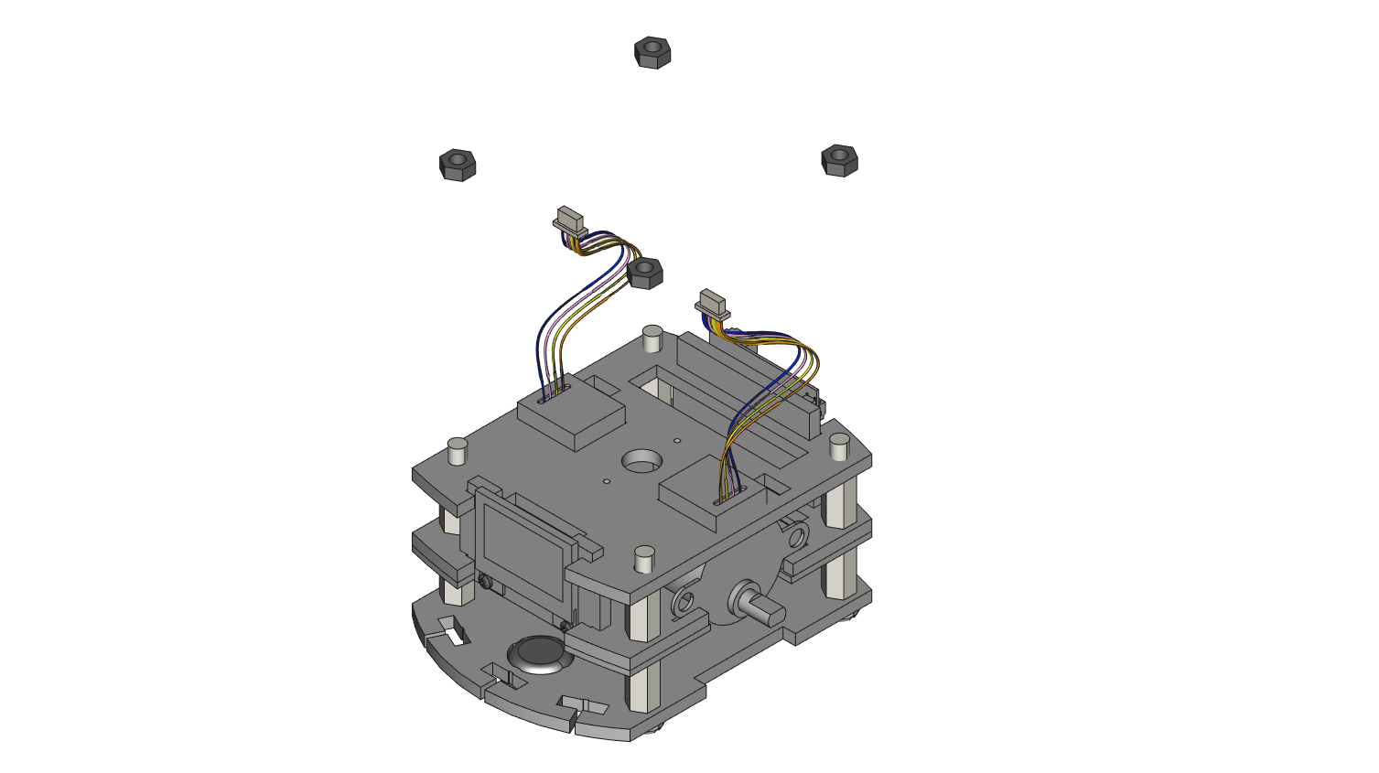

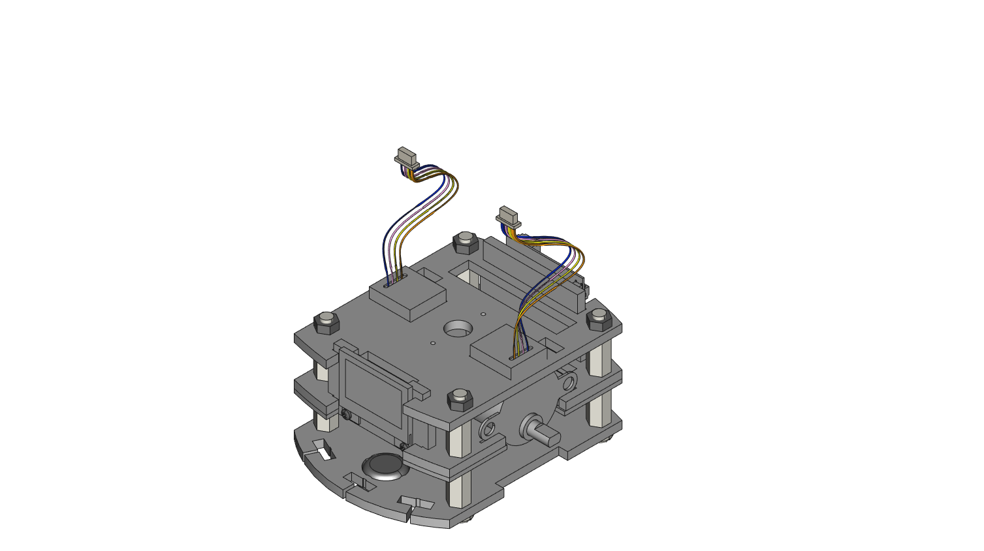

**STEP 19**: Bend the stepper motors through the small rectangle slots on CA5 and plug each 4-pin connector into the RobotZero board. From this view, the left motor plugs into port 2 and the right motor into port 1.

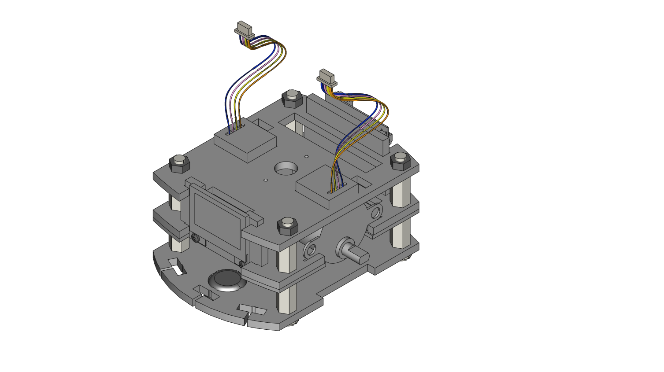

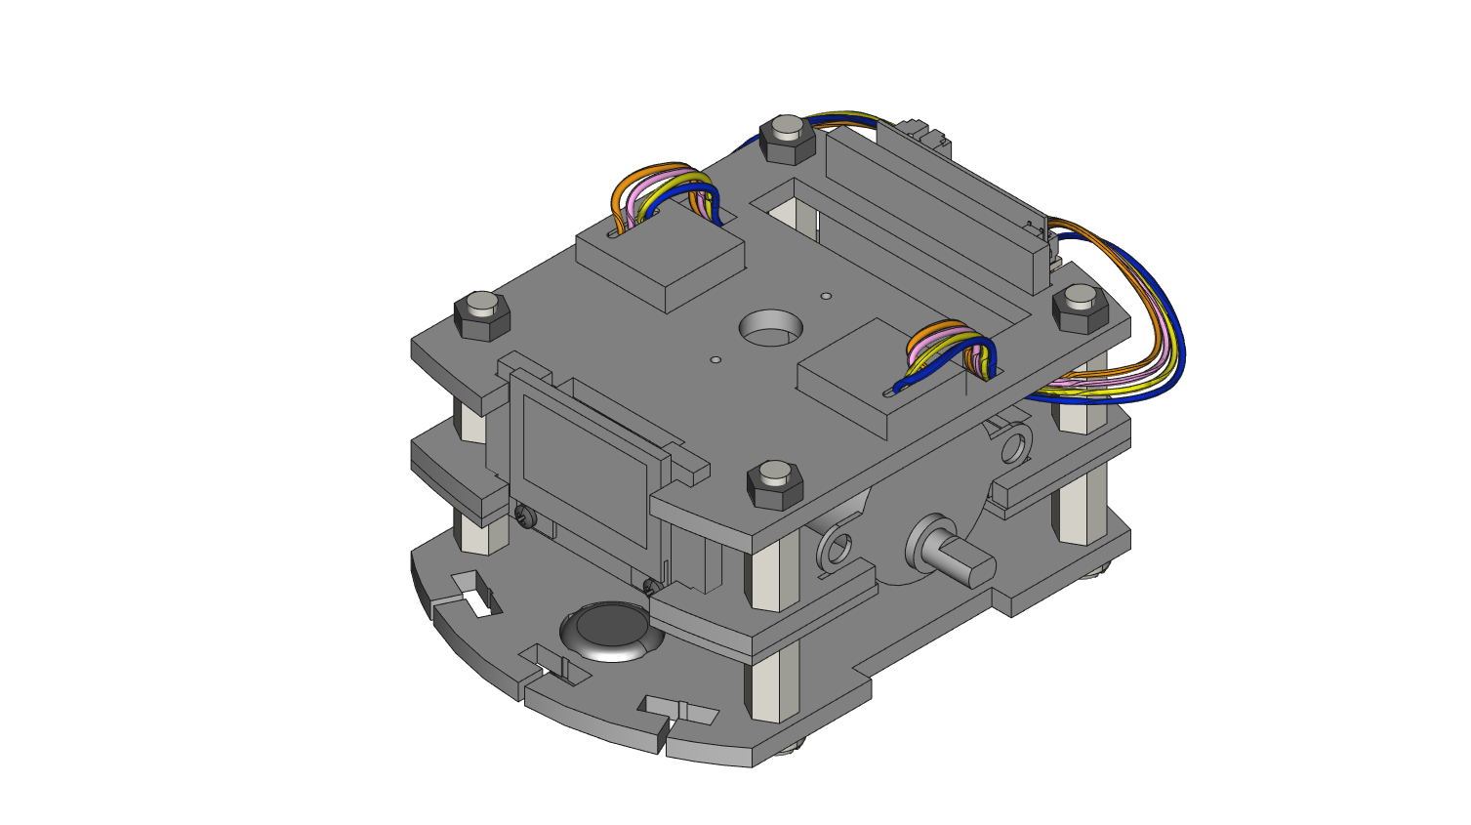

**STEP 20**: *Make sure to do the next few wheel steps in the order shown.* Take CA7 (left) and stack CA8 (right)on top of it.

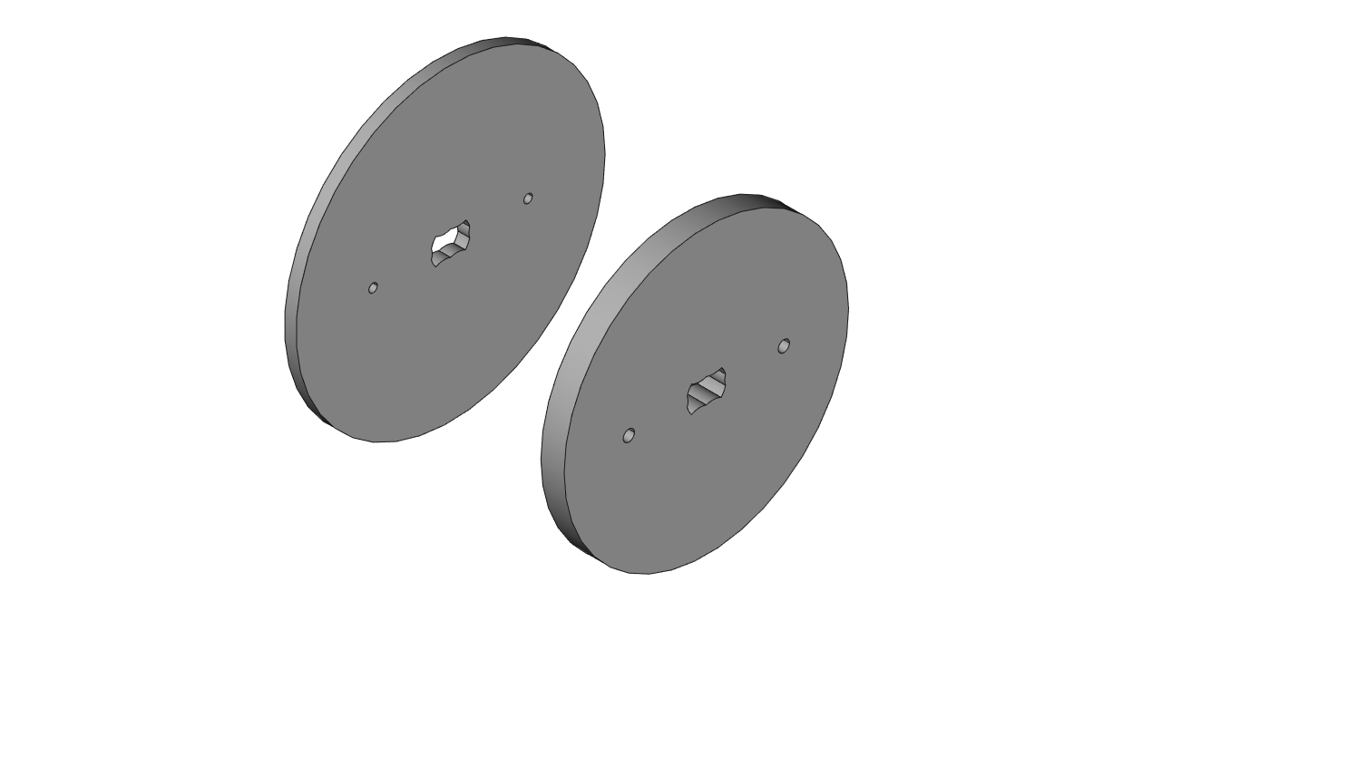

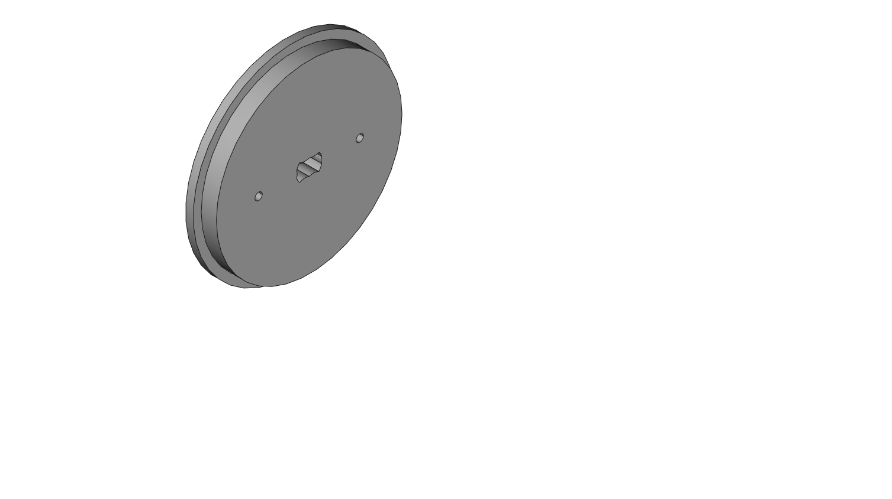

**STEP 21**: Next, stack CA9 (right) on top of CA8 from the last step.

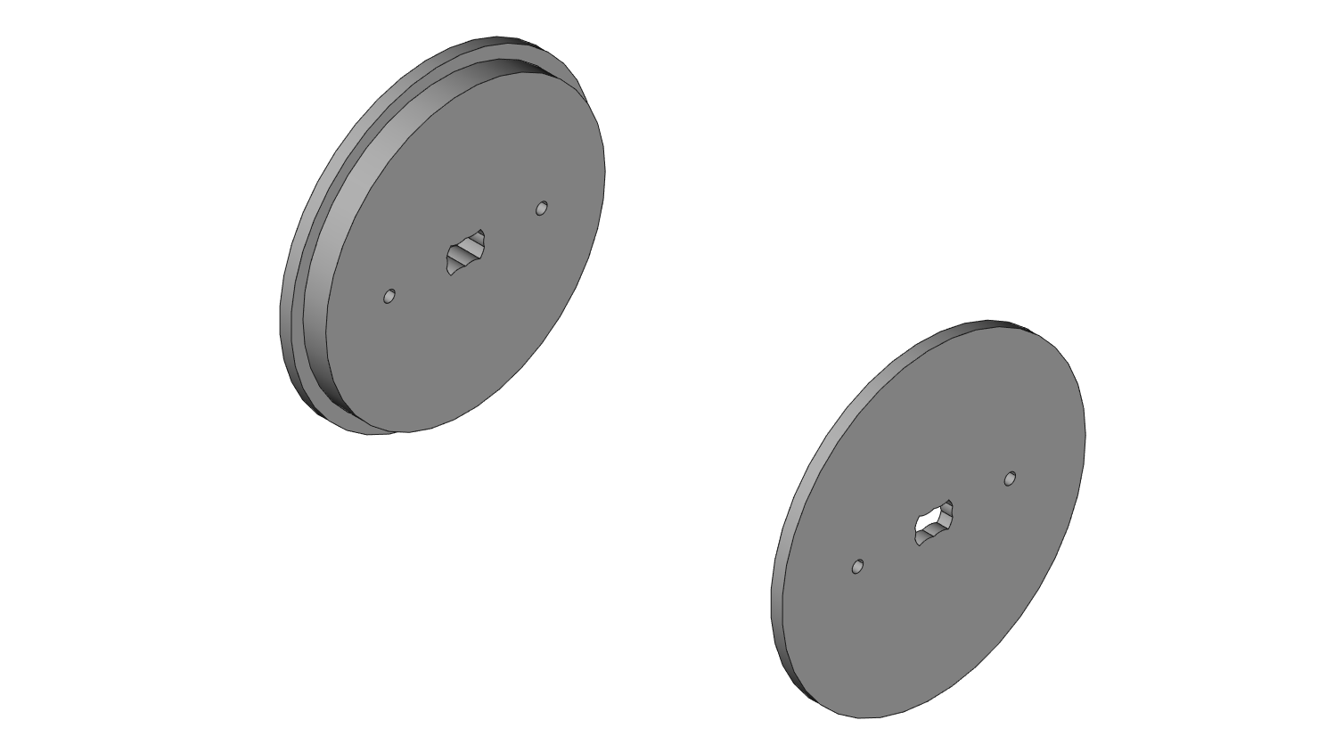

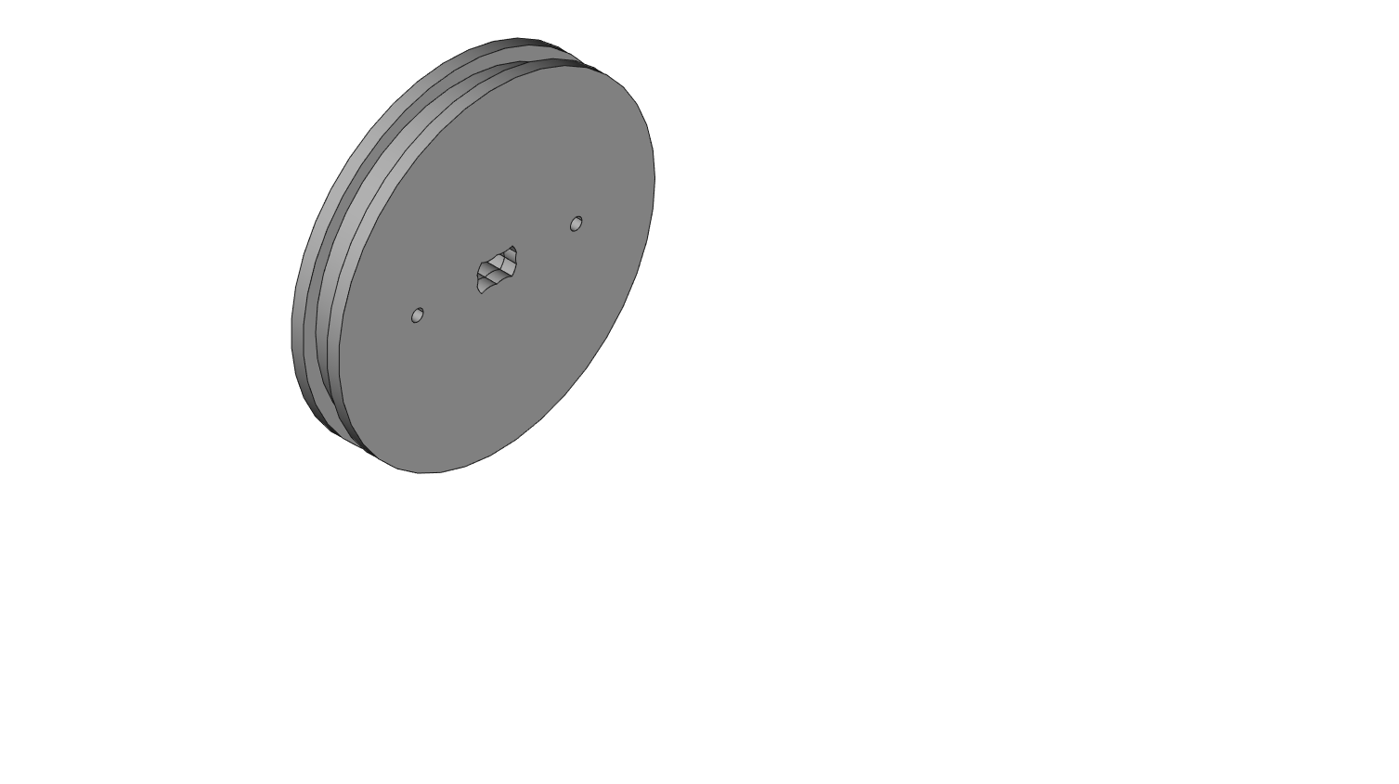

**STEP 22**: Secure the wheel pieces together by inserting through CA9 then the middle piece CA8 and tightening 2 M1.4 x 8mm screws into CA7. **WARNING: Screws strip easily here if using an incorrectly sized Philips screwdriver. Do not over-tighten the screws – this will help you avoid stripping screws, or cracking acrylic.**

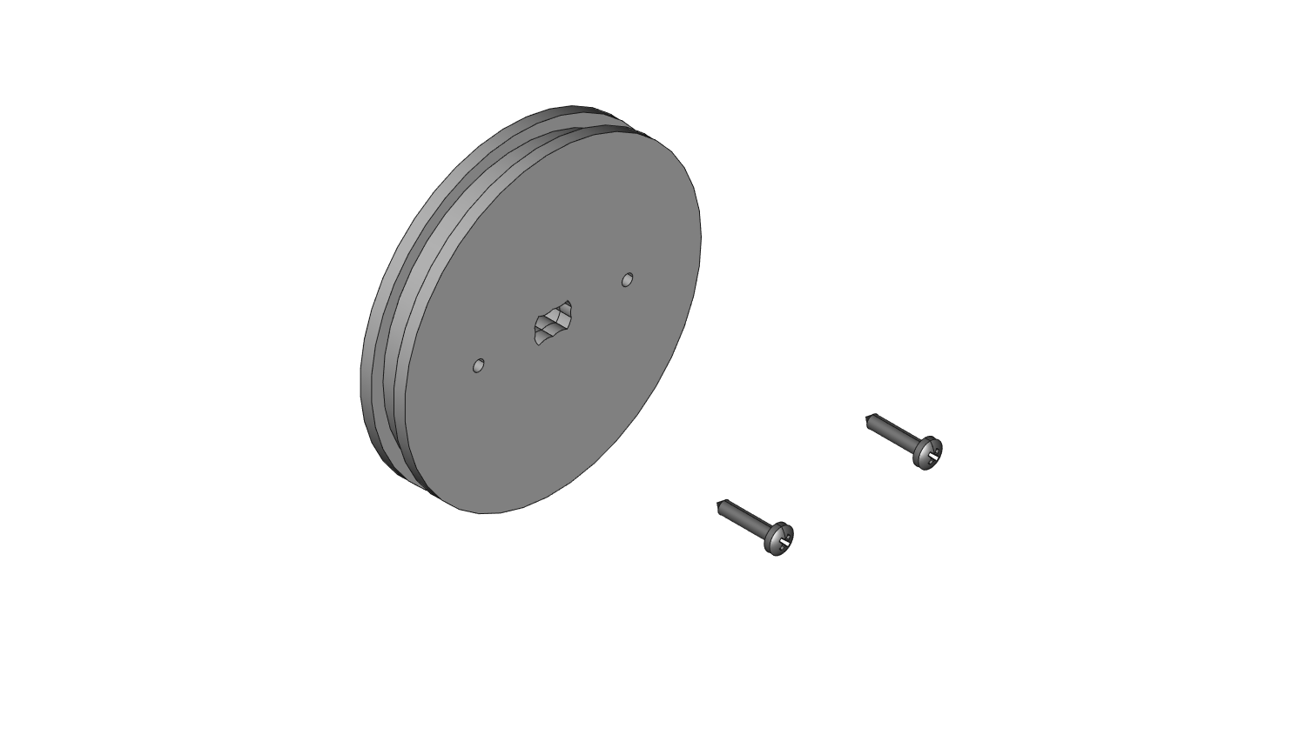

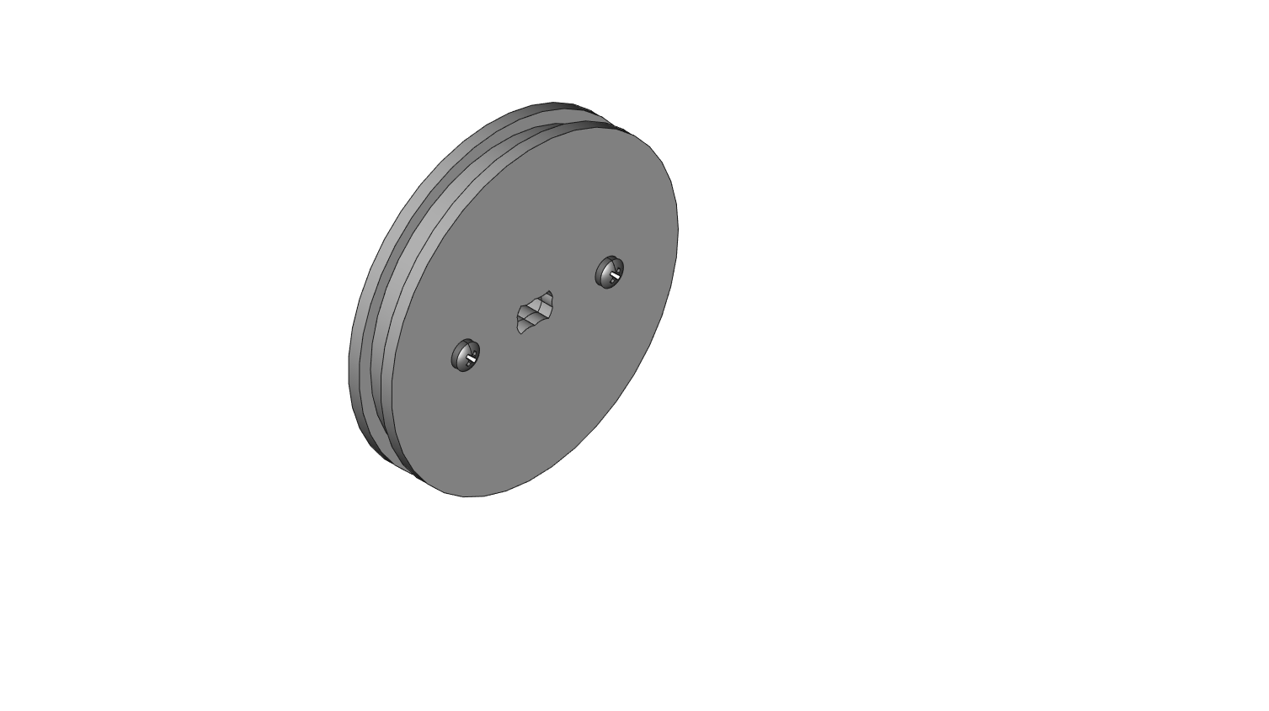

**STEP 23**: Stretch a large silicon O-ring around the wheel sandwich. Take care not to bend any of the acrylic pieces while stretching the O-ring.

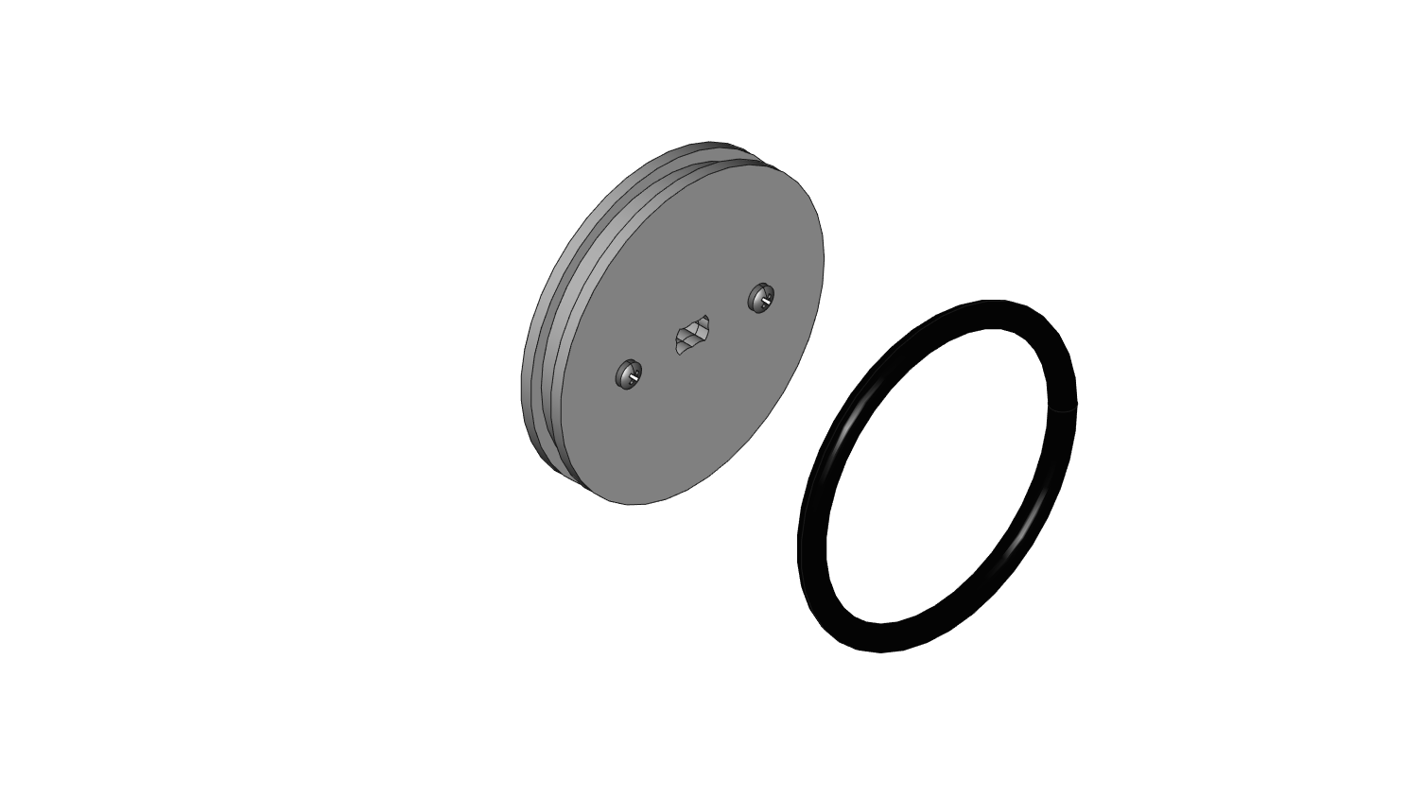

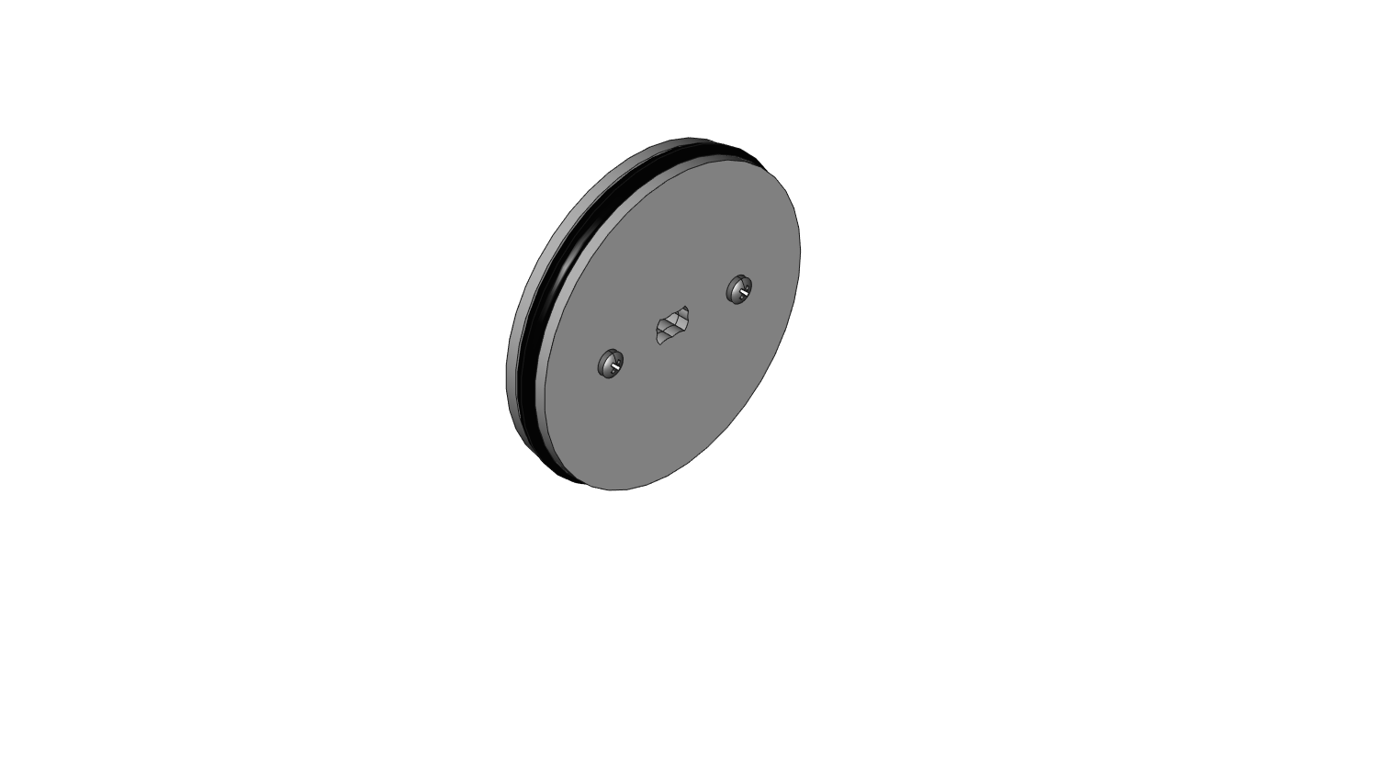

**STEP 24**: Push the wheel onto either motor on the car.

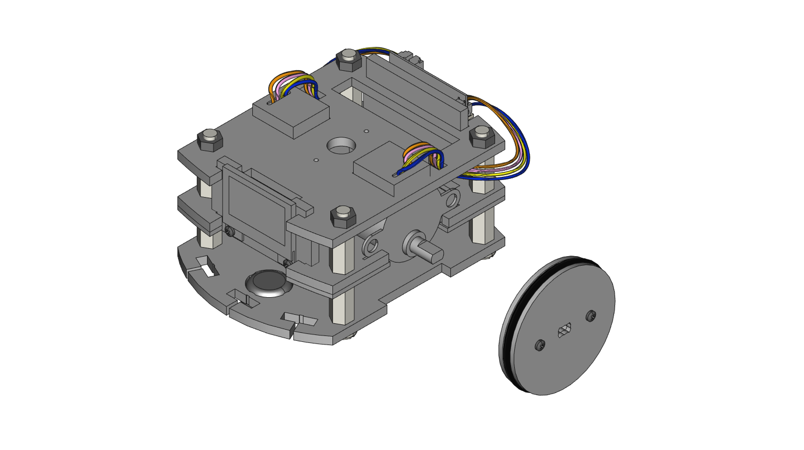

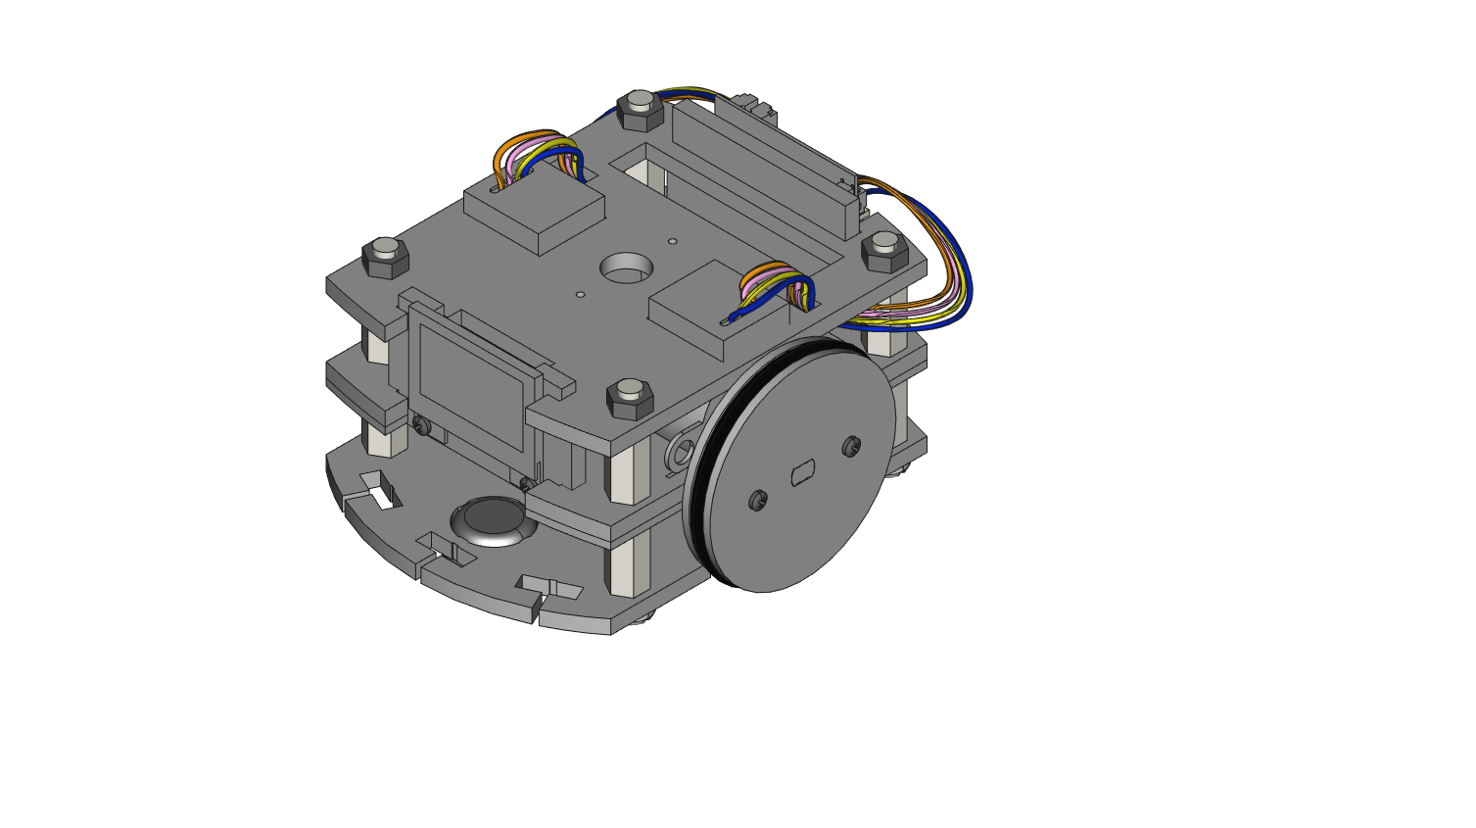

**STEP 25**: **Repeat steps 20-24 for the other wheel.**

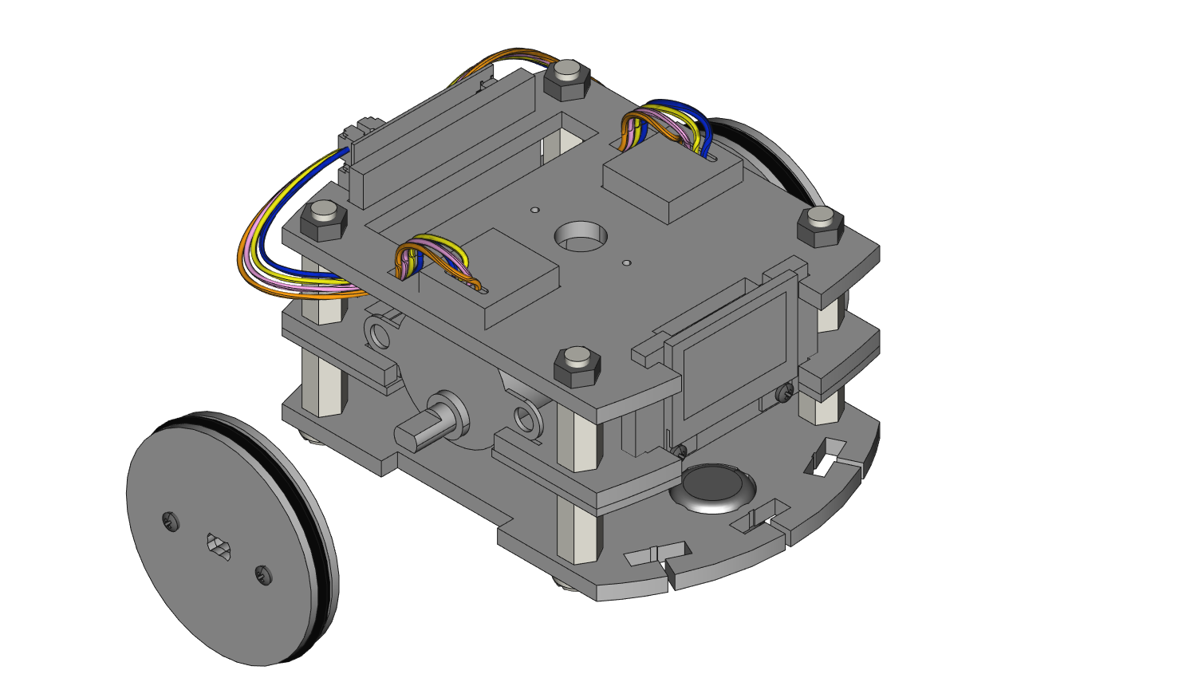

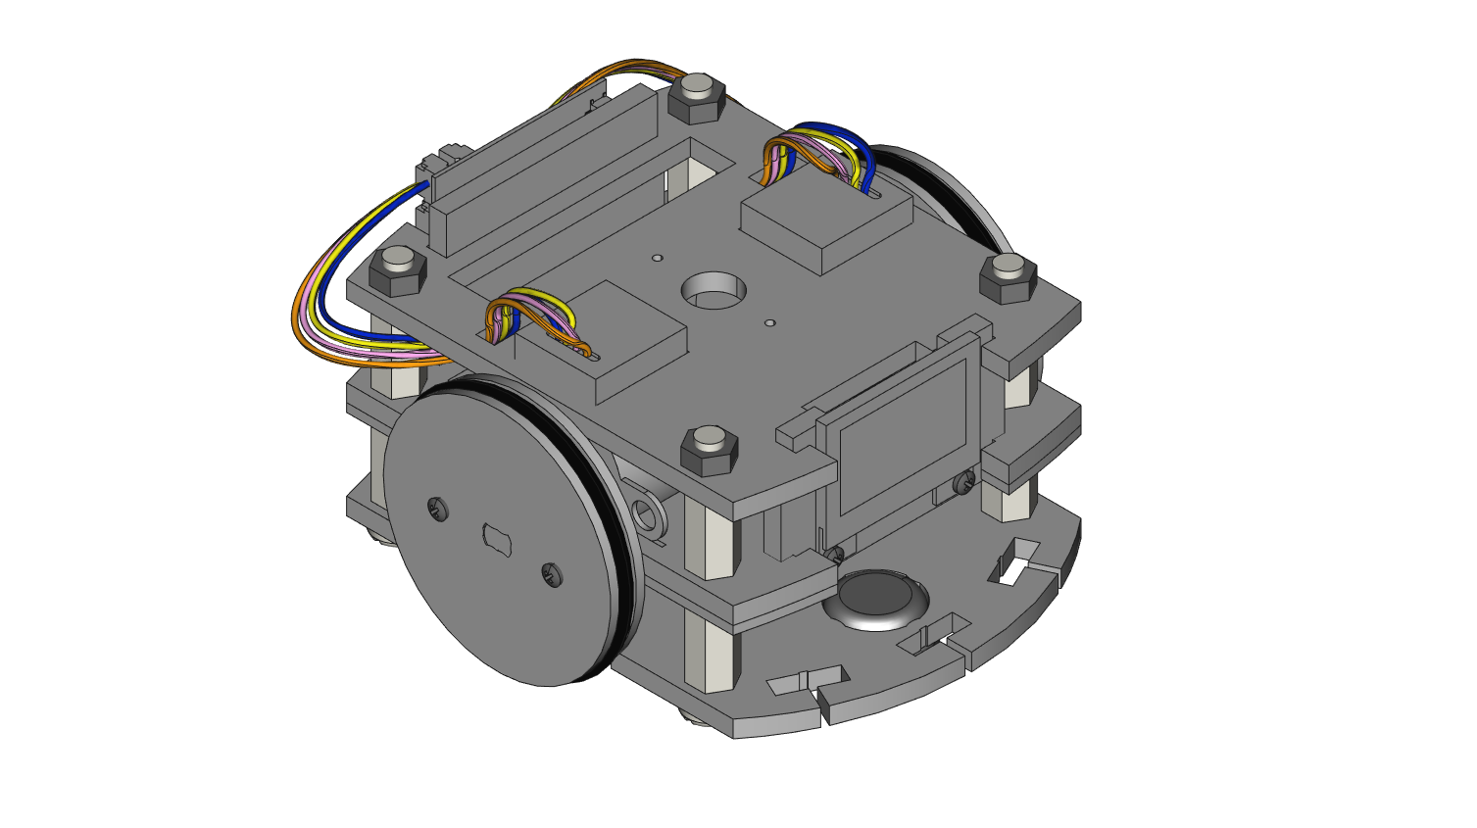

**STEP 26**: Plug the 1000 mAh battery into the RobotZero board. The battery rests in the large slots common on pieces CA2, CA3, and CA5. *NOTE: The motor wires are not shown here to give a clear view of the battery.*

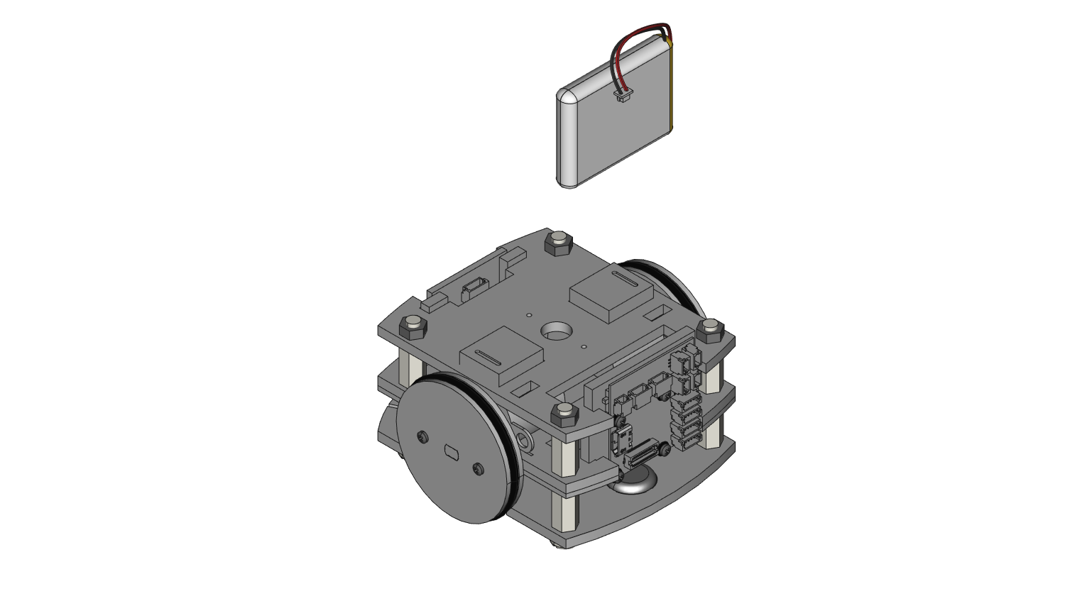

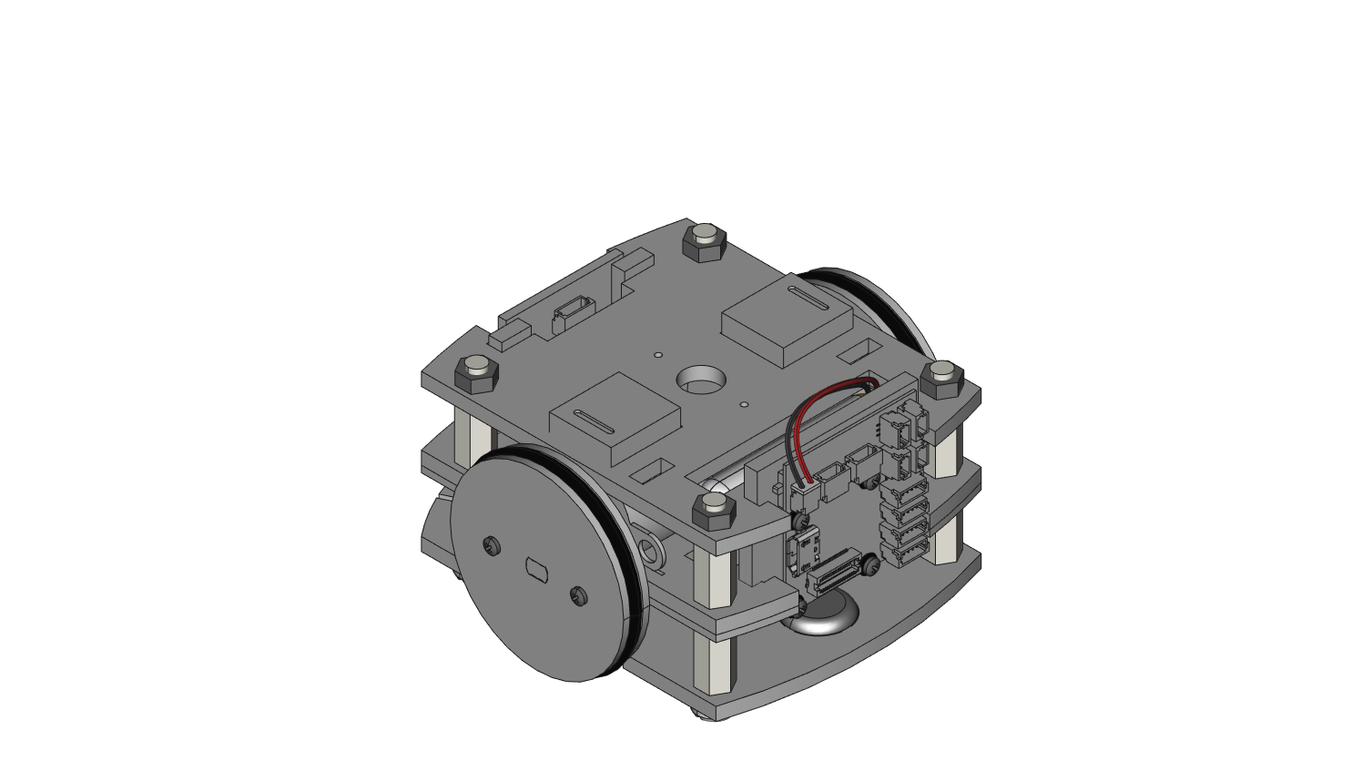

**STEP 27**: Plug in the 2 Color Sensor Wirelings into 2 100mm Wireling cables. Feed the 2 Wireling cables with Color sensors attached through the square spaces on CA1. Mount the 2 Color Sensor Wirelings using the 4 holes on CA1 and 4 M1.4 x 8mm screws. **WARNING: Do not over-tighten the screws.**

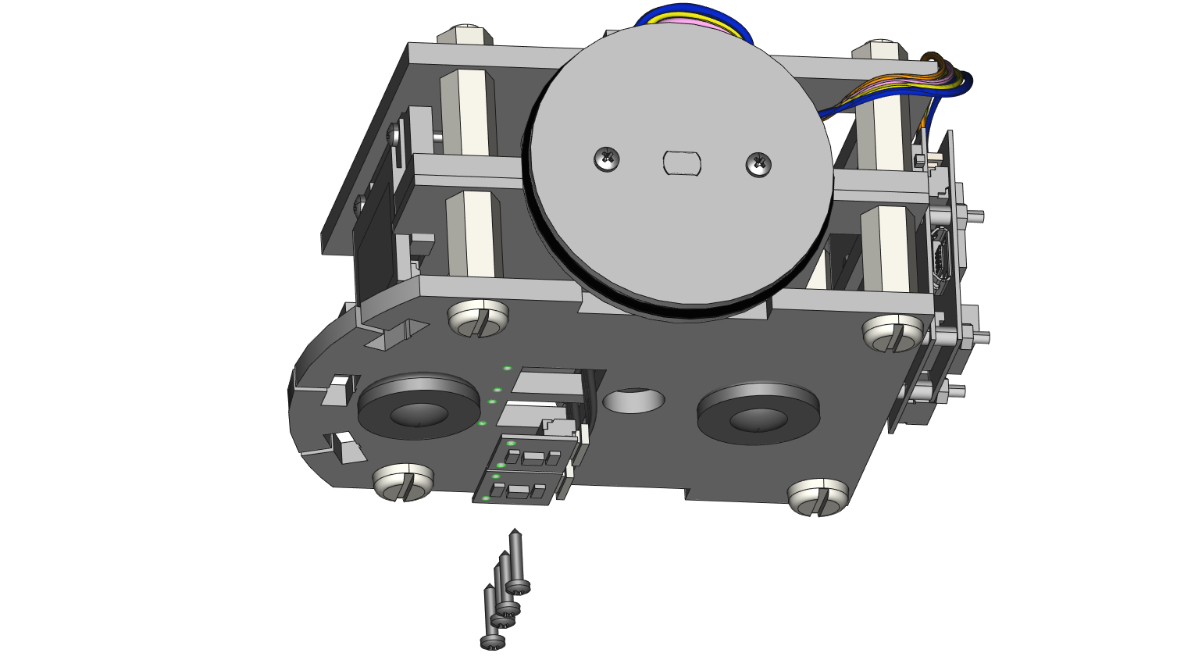

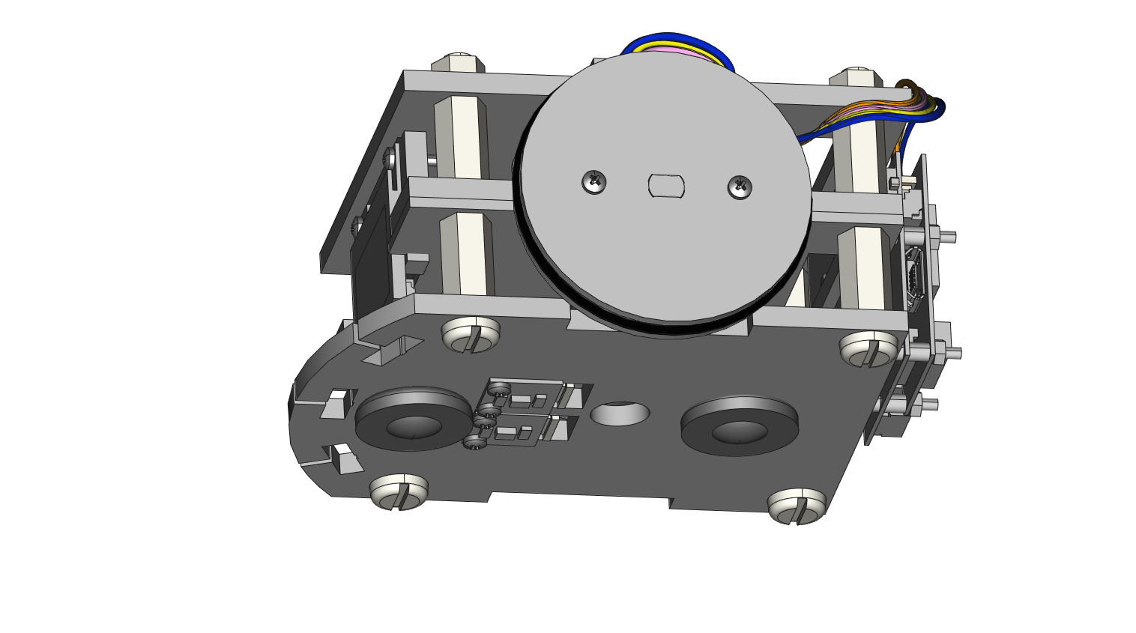

**STEP 28**: Use 2 M1.4 x 8mm screws to mount the Time-of-Flight Wireling to an M1 part. Mount the M1 part to CA1 using 1 M1.4 x 8mm screw and 1 small metal washer. The 100mm black 5-pin cable for the TOF sensor in not shown here but can be routed to the RobotZero through the space between CA1 and CA2. Connections are shown on the next step. **WARNING: Do not over-tighten the screws.**

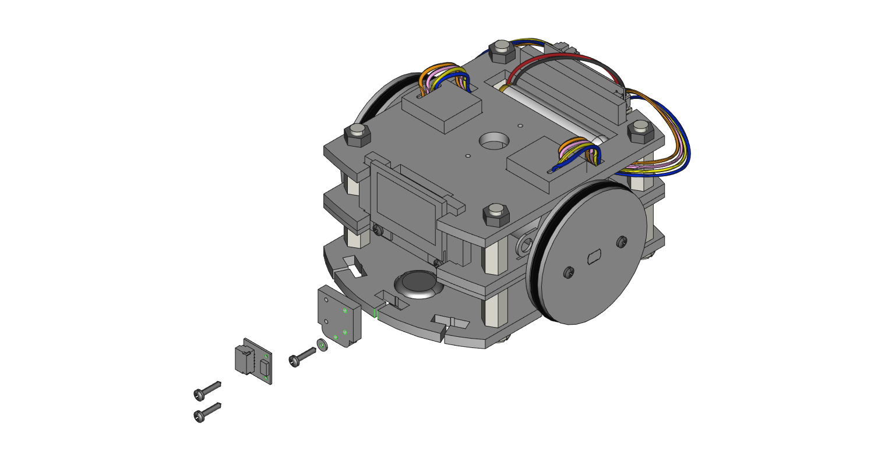

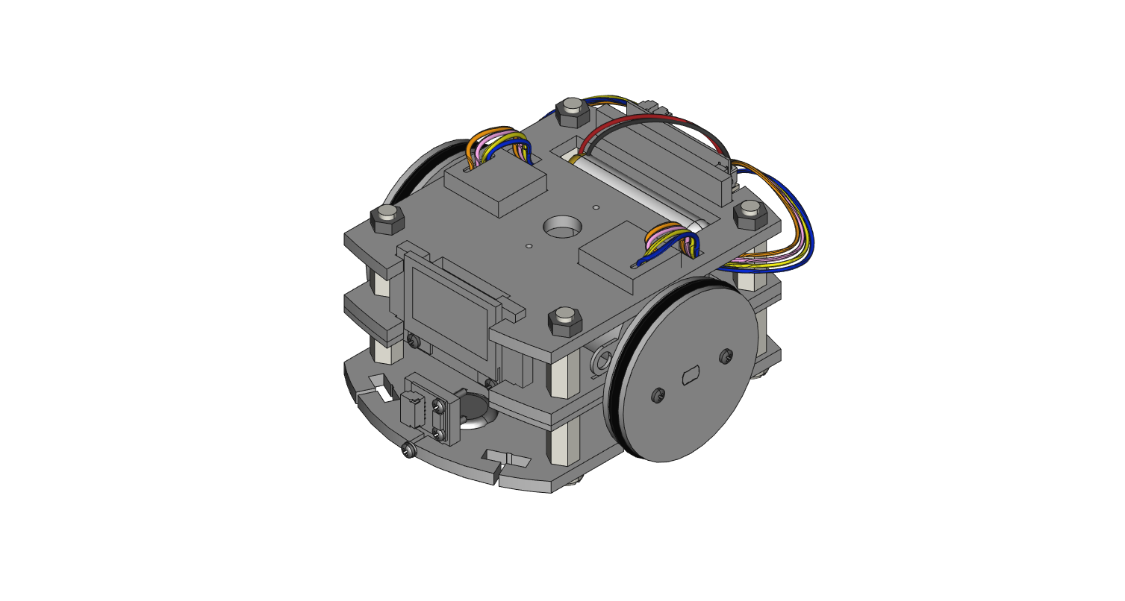

**STEP 29**: Route the 5-pin black wires through the car enclosure. In the image below, they are routed by wrapping them out and around, from the back, the right-side vertical hex spacers. On the mounted RobotZero board, the connections (outlined in green) from top to bottom are 0.96” Screen Wireling in port 0, Color Sensor Wireling in port 1, right-most Color Sensor Wireling in port 2, and the TOF Wireling in port 3.

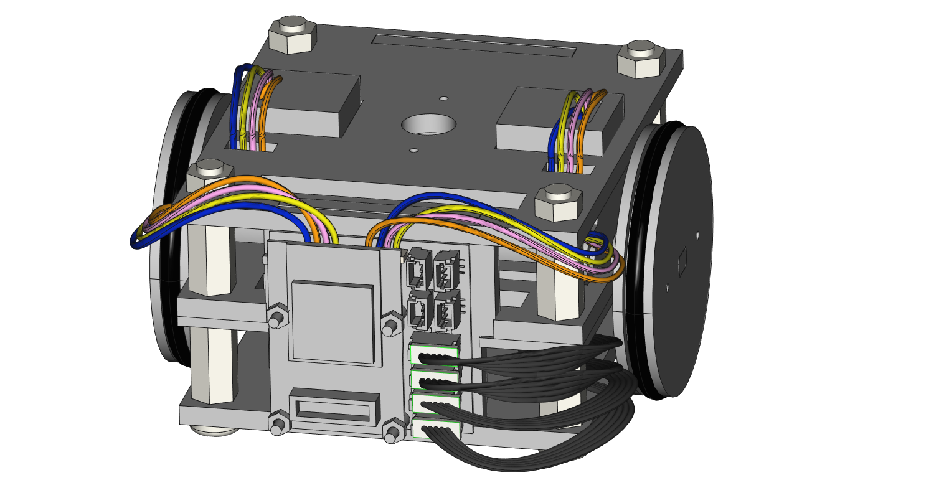

**Going further**: See our website at <https://learn.tinycircuits.com/> and search for TinyCar for more information